Development of Grid Corrections to Mixing Parameterizations with Potential Application to Arctic Climate Change

Richard T. McNider,ª Arastoo Pour-Biazar,^{a,}
ª Earth Systems Science Center, University of Alabama in Huntsville, Huntsville, Alabama

Corresponding author: Richard T. McNider, mcnider@nsstc.uah.edu

Submitted to Journal of Applied Meteorology and Climate

ABSTRACT
The response of the Earth’s climate system to GHG forcing appears largest in the Arctic, both in observations and models. However, in multi-model evaluations (CMIP3 through CMIP6), most models appear to underestimate the amount of warming. Here, we examine the role of turbulent parameterizations of the stable boundary layer (SBL) in impacting the magnitude of warming and the spread in model responses. Turbulent parameterization of the SBL has long been a challenge in models. Forms used in high-resolution research boundary layer models often do not work well in coarser grid operational or climate models. GCM vertical resolution often deteriorates to a few layers in the SBL and 500m or more in deeper stable layers (SL). This resolution may not capture well the correct strength/depth of the Arctic inversion, the entrainment warming as the SBL is destabilized by GHG forcing, or the correct energy budgets. It seems likely that the large spread in GCM Arctic simulations is in part due to the differences and misapplications of these grid-dependent parametrizations. In this investigation, we plan a new approach to the SBL parameterization problem by explicitly incorporating grid vertical resolution in the parameterization. This will be carried out by analytically and numerically recovering a stability correction function that depends on the grid spacing. Initial tests of an analytically recovered correction function indicate that the correction function provides longer-tailed stability functions for coarse grid models. Applying this correction to a simplified Arctic profile made coarser grid models agree better with fine-scale results.

SIGNIFICANCE STATEMENT
This article addresses how small-scale turbulence may impact large-scale climate change response in coarse grid climate models. The impact of climate change in models is dependent on the vertical grid resolution in models. The present investigation proposes and tests a model correction which makes model results less grid dependent. It may help bring climate model and small-scale boundary layer communities together.

- Introduction
Here, we provide background on Arctic warming and how it is related to turbulence parameterizations, which are problematic in coarse vertical grid climate models. A prime tenet of climate change theory is that warming in the Arctic will be much larger than over the rest of the globe – this is referred to as Arctic Amplification (AA). However, in Global Climate Model (GCM) evaluations (CMIP3 through CMIP6), most models appear to underestimate the amount of warming (Swanson 2013, Davy and Outten, 2020, Hahn et al. 2021) compared to observations. We focus on the possible roles turbulent mixing in the stable boundary layer (SBL) and deeper stable layers (SL) might have in climate simulations.
Turbulent parameterizations in gridded models for stable layers have historically been known to depend on model resolution (e.g., Zilitinkevich and Esau, 2003; Savijarvi, 2009; Beljaars et al., 2012) Here, we provide a preliminary analysis of a path to make stable boundary layer (SBL) and deeper stable layer (SL) modeling less dependent on grid spacing. This will be carried out by analytically defining a stability correction function that depends on the grid spacing. It has particular importance for climate models trying to capture warming rates in the Arctic because of GCMs’ coarse resolution. The new correction function is tested in idealized Arctic environments (GABLS1- see Cuxart et al., 2006). The GABLS1 tests show that the model solution without correction is dependent on grid resolution. The larger grids depart more from the baseline 2m grid. However, the simulations with the correction show that the larger grids come closer to the 2m grid solution.
In the summary, we suggest that further understanding, refinements, and testing of our approach are needed to reduce grid dependence in model performance. In the simple GABLS1 setting, the model top was 400m, so the largest grid was only 60m. Testing should be done in more realistic deep Arctic domains where climate model grids can be 100m to 500m.

- Background on Arctic Amplification and Role of Boundary Layer Processes
Arctic Amplification (AA) has been considered a signature of greenhouse gas warming, as articulated by Manabe and Wetherald (1975) and Bindoff et al. (2013). In early studies (Manabe and Stouffer, 1994; Hall, 2004), the primary process for enhanced high-latitude warming was snow/ice albedo feedback. In a warming world, snow/ice cover would be reduced, decreasing surface albedo and leading to further warming.
However, as discussed by Graversen and Wang (2009), polar amplification can occur without changes in surface albedo. Other processes may also contribute to polar amplification (Taylor et al., 2013; Pithan and Mauritsen, 2014), including confining long-wave heating to a smaller depth because of the polar inversion. Sea ice loss can change not only the albedo but also surface fluxes and heat budgets (Boe et al., 2009; Bintanja et al., 2012). Finally, high latitude warming is affected by meridional heat transport. Part of the development of deep stable layers is due to the advection of warm air aloft as part of the polar direct cell. Cai and Lu 2007 noted that the enhanced poleward heat transport aloft under climate change enhances the Arctic inversion, amplifying high-latitude warming. AA is exceedingly complex (Boeke et al. 2021) and models often have to deal with it not from first principles but from complex parameterizations.
  - Positive Feedback from Inversion Entrainment
Studies have included the Arctic inversion as a mechanism for surface warming and AA (Boe et al., 2009). For example, Davy and Esau (2014) and Bintanja et al. (2012) discussed that the strong Arctic inversion confined CO₂ downward LW to a shallow surface layer, thereby amplifying its impact. However, there does not seem to have been explicit consideration of the role turbulent entrainment has in amplifying surface warming beyond simply confining the warming to a shallow layer. Figure 1 from McNider et al. 2012 (hereafter MCN12, a mid-latitude study) shows an examination of a stable profile subjected to enhanced greenhouse gas forcing of approximately 4 Wm⁻². The top figure shows that the forcing has destabilized the inversion. The lower figure shows that the destabilization increases the surface temperature but cools the layers aloft. As shown in MCN12 most of the warming seen at the surface was due to the entrainment of heat from aloft (the cooling at the top of the profile in 1b.) In fact, MCN12 showed nearly 10 times more heat in the near-surface atmosphere is due to this entrainment than the accumulation of direct greenhouse gas energy.
In the Arctic, this would warm the ocean/melt ice. Models with sufficient vertical resolution should capture this entrainment process, and part of the surface warming discussed in Davy and Esau (2014) and Bintanja et al. (2012) is undoubtedly partly due to entrainment. Entrainment amplification depends on the strength of the inversion and resolution in the model. As discussed by MCN12 the amount of this entrainment warming is highly dependent on the particular stable boundary layer parametrization employed. Stable boundary layer parameterizations with less mixing (stronger initial inversions) would be more sensitive to extra GHG forcing due to greater entrainment. On the other hand, GCMs that have too much mixing in the base state (before enhanced GHG forcing) would underestimate the entrainment warming and AA. This is also consistent with Bintanja et al. 2012 (see discussion below).

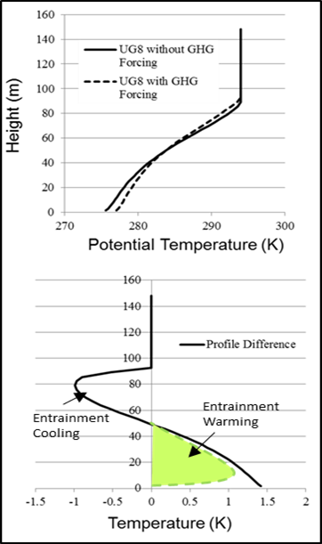
Fig. 1. (top) The impact on potential temperature profile between the case of added GHG energy and base case for a geostrophic wind of 8 ms⁻¹. (bottom) Expanded view of profile difference. Colored green area shows the approximate warming due to entrainment which is much larger than the direct CO2 warming (the remaining white area). From McNider et al. 2012.

  - Uncertainties in GCM Performance and Warming Sensitivity at High Latitudes
There have been several assessments of model inter-comparisons of AA under the CMIP3 through CMIP6 programs ( Swanson 2013; Franzke et al. 2017; Cai, S. et al. 2021; Hahn et al. 2021; Cai, Z. et al. , 2021). Figure 2 shows the comparison of CMIP3 and CMIP5 trends and the comparison by Swanson (2013) to observational-based analyses – ERA-Interim and HadCru4. We note that ERA-Interim is an ECMWF reanalysis product that incorporates observations into a model framework. It has since been replaced by a new reanalysis – ERA5 - which has been available since 2018. However, Hahn et al. 2021 used ERA-Interim apparently because of a slightly smaller bias for ERA-Interim in the Arctic than its successor, ERA5. The Swanson (figure 2) and Hahn et al. latitudinal plots show that model spread is largest at high latitudes in both hemispheres, with the spread being greatest in the Arctic. Their analyses show that the mean warming in the CMIP3 and CMIP6 models is larger than observations (ERA Interim, HADCRUT4, HaDCRUT5). Yet, the CMIP5 and CMIP6 greater warming in high latitude, perhaps, comes at the expense of overwarming at lower latitudes. Hahn et al. 2021 noted that if warming in the CMIP6 models is normalized by the global-mean value, the CMIP5 and CMIP6 yield a similar degree of AA. CMIP3 and CMIP5 models may simulate excessively surface-trapped Arctic warming as a result of overestimating mean-state inversion strength (Pithan et al., 2014; Screen et al., 2012).
A recent paper by Douville 2023 discusses the continued over-prediction in the Arctic from CMIP3 through CMIP6. He notes the underlying mechanisms, their seasonality, and the quantification of their relative contributions to AA have been the subject of ongoing debate. Further, a better understanding has not translated into much more reliable projections from one generation of CMIP models to the next.
However, there is some recent information that may alter the view that models continue to under-estimate polar warming. Tian et al. 2024, seems to cast doubt on ERA5 and ERA-Interim warming in the Arctic. It is based on using a new infrared (IR) polar orbiting satellite data set created by Nielsen-Englyst et al. 2023. The satellite data set shows much less warming in the Arctic than ERA. We could not find any references to a response by ECMW to this finding. Since the paper is new, caution is perhaps warranted at this point. We would point out, based on our modeling experience, that translating surface IR temperatures to 2m air temperatures depends on turbulent theory. Likewise, for ERA, extrapolating free atmosphere values to 2m air temperatures depends on turbulent theory.

. 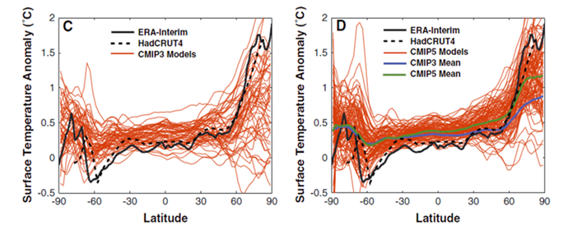
Fig. 2. (Adapted from Swanson 2013) Panel C shows the surface air temperature anomalies as a function of latitude for the CMIP3 simulations (red curves), as well as the ERA-Interim reanalysis (heavy black curve). The anomalies in his paper are the change in near-surface air temperatures for the 2002–2011 decade relative to the 1979–2001 mean. Panel D is the same, but for CMIP5. Note ERA Interim and HadCRUT4 are observational data sets.
Bintanja et al. (2012) showed that in climate models, the strength of the inversion was dependent on mixing. They carried out a controlled experiment, changing mixing in a single model. Figure 3 from Bintanja et al. (2012) shows that in a GCM, the AA is tied to the amount of turbulent mixing in the high-latitude SBL. Less mixing produces a larger amplitude response in the AA. As shown in Figure 3, they demonstrate how differences due to uncertainty in SBL can impact AA in climate models.
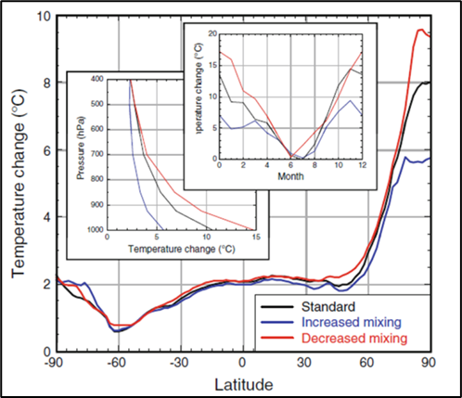
Fig. 3. Zonal and annual mean surface air temperature change for three mixing cases (doubled CO2)). Inserts show the vertical profile of annual mean temperature change (averaged over 70–90_N), the seasonal variation of surface air temperature change (averaged over 70–90_N), and the seasonal variation of surface air temperature change (averaged over 70–90_N). (Source Bintanja et al. 2012).

  - Modeling Difficulties for SBL Regimes
The spread in model results in the Arctic may partially be due to modeling difficulties in stable layers. In the 1980s, models began using local mixing schemes (e.g., Blackadar 1979; Mellor and Yamada 1982) for the stable boundary layer and employing turbulent kinetic energy models or stability function closures based on fundamental Monin-Obukhov Similarity Theory (MOST) (Businger 1973). As a result, models began to have a problem of becoming too stable, with surface conditions becoming too cold and calm (Derbyshire 1999). Mixing of heat and momentum to the surface was too weak (Louis 1979; Beljaars and Holtslag 1991; Viterbo et al.1999; Beljaars et al.2012; Audouin et al 2021). In these coarse grid operational models, it appeared that additional mixing was needed (Savijarvi 2009; Viterbo et al. 1999). Thus, mixing formulations that had more mixing were employed, such as longer-tailed stability functions – see below. Bintanja et al. (2012) also discussed the bias in the ECMWF IFS model and referenced the adjustments made by Viterbo et al. (1999) to add mixing for operational forecast purposes. They noted that such adjustments may not be appropriate in climate models, in that too much mixing can impact the sensitivity of the climate model to GHG forcing.
In K closure models in the stable layer, such as those used in GCMs and weather forecast models (Esau and Byrkjedal 2007), the vertical mixing coefficient is often parameterized (Blackadar 1979; McNider et al. 1981; Savijarvi 2009) by
${K_{m}=f}_{m}\left(Ri\right)l^{2}s$ ${K_{h}=f}_{h}\left(Ri\right)l^{2}s$ ${f_{m}=Pr(Ri) f}_{h}$ (1)
Here $K_{m}$ , $K_{h}$ are the mixing coefficients for momentum and heat. The symbols ${ f}_{m}(Ri)$ , ${ f}_{h}(Ri)$ are referred to as the stability functions with Ri, the Richardson Number, given by
$Ri=(\frac{g}{θ_{0}})(∂θ/∂z$) / $({∂V/∂z)}^{2}$.
The symbol l is a mixing length, s is the local shear, and Pr is the Prandtl Number. Here, we will refer to ${ f}_{h}\left(Ri\right)$ generically as $f_{s}\left(Ri\right),$ then ${ f}_{m}\left(Ri\right)$ can be recovered using the Prandtl Number (see Pleim 2007). Esau and Byrkjedal (2007) provide an excellent overview of the first-order closure /recovery of ${ f}_{m}(Ri)$ and${ f}_{h}(Ri)$ from LES databases. Note that this stability function closure is basically a TKE model with the advection of turbulence ignored.
Originally, Blackadar (1979) and others based the stability function on boundary layer observations in which turbulence was suppressed beyond an Ri ~ 0.25. Fig. 4 shows the typical stability functions used in the SBL in the past. The England-McNider and Duynkerke would be short-tailed forms, more consistent with Monin-Obukov Similarity Theory (MOST) (MCN12) and LES results, while the Beljaars-Holtslag and Louis forms would be considered longer-tailed forms having enhanced mixing at larger Ri. As discussed by Savijarvi (2009), the added mixing needed by operational models was often implemented by using the longer-tailed stability functions (Beljaars and Holtslag 1991; Viterbo et al. 1999).
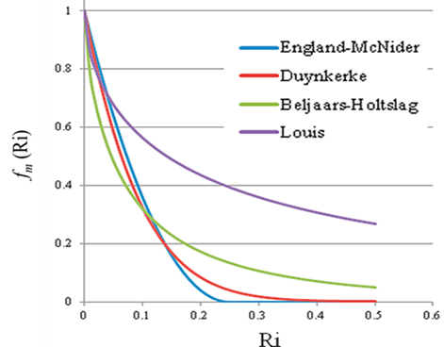
Fig. 4. Typical stability functions used in modeling the SBL. Ri is the gradient Richardson number. See England and McNider (1995), Duynkerke (1991), Beljaars and Holtslag (1991) and Louis 1979). The Duynkerke, Beljaars and Holtslag, and Louis represent curve fits to the original parameterization. See also Van de Wiel et al. 2002a.

Early on, as local turbulent closures were being implemented, investigators (e.g., Blackadar 1979; Shir and Bornstein 1977; McNider and Pielke 1981) argued for the need for additional mixing in coarse grid models beyond the cutoff at a critical Richardson Number (Ri_{c}) of ~0.25. The physical argument was based on the existence of unresolved fine-scale shear and temperature gradients in the real atmosphere that contributed to mixing. It was also felt that horizontal heterogeneity might also contribute to mixing (Mahrt 1996; Steeneveld et al 2008b). However, as shown below, perhaps part of the reason is how the discretized form of Ri is defined, which is explicitly dependent on grid spacing and not just missing unresolved structure. This is the focus of the present investigation.
Besides the longer-tailed stability functions, other mixing adjustments, such as making Ri_{c} an ad hoc function of grid spacing (McNider and Pielke 1981) or setting minimum diffusivities (Pleim 2007), were employed to add mixing and to keep the model from being too cold. We note also that Galperin et al. (2007a) also discussed that Ri_{c} is not a fundamental measure of when turbulence is suppressed due in part due to other forms of mixing.
Today, however, it appears that with increased vertical resolution and/or improved radiation schemes, some operational forecast models are now making the opposite error with these adjustments, having too much mixing (Steeneveld et al 2008a; Savijarvi 2009; MCN12). The spread in temperature in the GABLS1 single column model intercomparison (Beare et al.2006) and GCM Arctic Amplification (Swanson 2013; Hahn et al. 2021) is likely in part a result of historical variations in the issue of parameterizing mixing in SBL.
  - Other Modeling Frameworks
The present work on a grid-corrected stability function has used the diffusion coefficient (K, stability function) approach in (1). Some models may have more complex TKE formulations for local mixing in the stable layers (Mellor and Yamada 1982; Kantha and Clayson 1994; Basu et al. 1999) that may be a more robust modeling approach. But they have similar issues with vertical resolution and with the stability function forms. One well-known TKE closure is the MYJ formulation (Janjic, 2001) based on Mellor (1973) and Mellor and Yamada (1982). The MYJ form has been used in the 3-dimensional operational forecast models. Another framework is the Quasi-Normal Scale Elimination (QNSE) (Sukoriansky et al., 2005); Sukoriansky 2008), which solves for turbulent energy in Fourier space. Galperin et al. 2007b showed that the QNSE system, with coarser resolution than LES, performed as well or better than LES. However, even the TKE schemes and QNSE have to parameterize the sub-grid or small wavelength mixing (Tastula et al., 2015a). They use
$K= αlS \sqrt{TKE}$
Where α is a non-dimensional coefficient, S is the inverse of a stability function, l is a turbulence length scale, and TKE is the turbulence kinetic energy. As discussed by Tastula et al. (2015a), one of the differences between MYJ and QNSE is the form of the stability function. The MYJ has a shorter-tail form with K’s shutting off at small Ri, while the QNSE form has a longer-tail with K’s being maintained well beyond an Ri of 1. Thus, these complex schemes may also need adjustment for grid spacing. Recently, Casasanta et al. (2025) provided an extensive review of Monin-Obukov Similarity Theory (MOST) and how it can be derived from a new closure - Energy and Flux Budget (EFB). Importantly, it shows that the specific similarity forms can be derived without empirical fitting.
Higher-order turbulence physical space closures and QNSE involve more complex mathematical equations and calculations than simpler schemes. This increases the computational cost and processing time, which can be problematic for the long-duration runs required for 3-D global climate models (GCMs). We are not fully familiar with the computational costs of QNSE. It has been used to good effect in a 1-D model (WRF) simulation in the Sichuan Basin (Wang ae al. 2024). We note that recently it was used as one of the PBL schemes in a study of winds in 3-D high-resolution simulations on Tibetan Plateau (Dong et al. 2025).

  - Impact of Mixing Parameterizations on Arctic Profiles and Energy Budgets
Different SBL parameterizations can greatly impact profiles of temperature. Figure 5 shows the development of an idealized Arctic stable boundary layer for several different mixing parameterizations using a single-column model for a GABLS1 boundary layer test case. It employs the UAH single-column model – see McNider et al. 2012 for a description. See Cuxart et al. (2006) and below for a description of the test case.
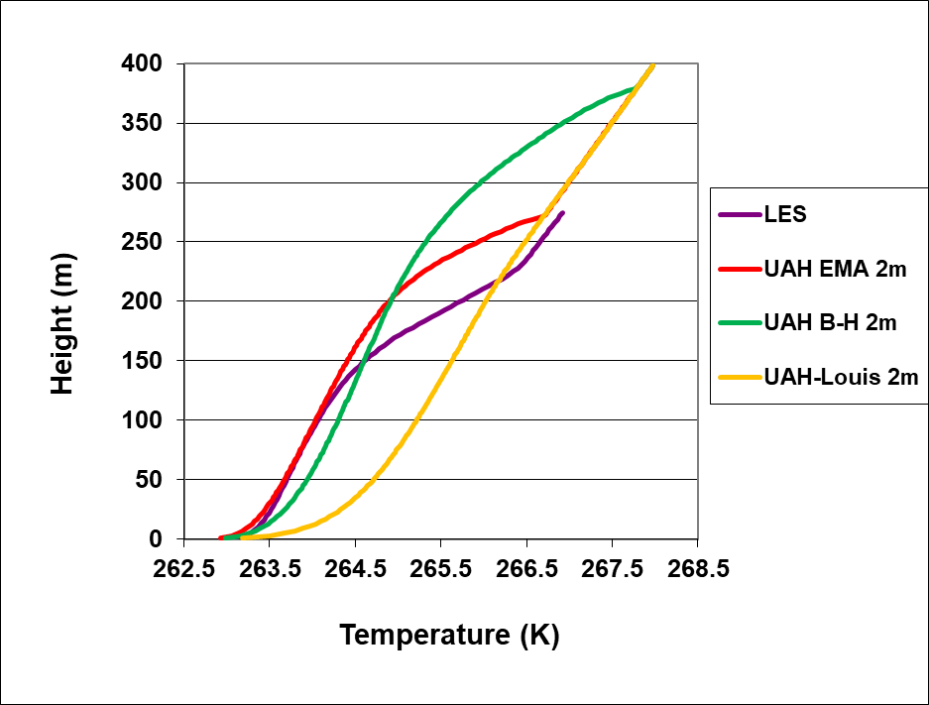
Fig. 5. Comparison of the different stability functions run in the UAH model against the GABLS1 single column model Arctic inter-comparison case [see Cuxart et al., 2006]. The LES came from the LES ensemble reported by Cuxart et al. [2006]. The UAH EMA is the exponential stability function used in the present study. The B-H and Louis curves are runs with the UAH model using the Beljaars-Holtslag stability function and the Louis function. Note also that these longer-tailed forms were employed in the high-resolution UAH model, not in the coarser grids for which they were developed.

In Figure 5, the UAH-EMA form is the exponential approximation (see below) of the original England-McNider (England and McNider 1995) form in Figure 4. The EMA form is close to the Duynkerke form. The shorter-tailed UAH-EMA form is more consistent with the LES simulations, which have even less mixing. The Beljaars-Holtslag (B-H) and Louis stability functions were developed to add mixing needed in coarse-resolution weather forecasting and climate models. The performance of these longer-tailed profiles in their original coarse resolution setting would be different than the UAH model with high vertical resolution (2m). But this does show the sensitivity of the SBL to parameterizations and the important role of model vertical resolution. We also note that the MYJ and ONSE also do very well compared to LES in the GABLS1 setting (Tastula et al., 2015b).

- Importance of Correct Transition Between Strongly and Weakly Stable States
Recent studies of the SBL have shown the importance of correctly capturing the transition between weak and strong stability states as a function of external parameters (Van de Wiel et al 2012; Van de Wiel et al. 2017; Acevedo et al 2021). This is because the transition between the two states has a large impact on average SAT, surface heat flux, and temperature profiles. Vignon et al (2017) concluded that correctly capturing the transition was critical to establishing and maintaining the pervasive inversion in the Antarctic. They further showed that this transition was both a function of turbulent parametrizations and model vertical grid resolution.
Vignon et al. (2017) also used several stability functions. They employed a long-tail form between the Louis and Beljaars, and the Holtslag form seen in Figure 4. This form is referred to as L82 in their paper. They also employed two shorter-tail forms, the first one similar to the Duynkerke form in Figure 4. They also used the England and McNider form. They showed that higher resolution simulations and short-tailed stability functions agreed best with the observations. But, in coarse grids, the short-tail forms did not produce enough mixing.

- Role of Model Vertical Resolution to Improve Understanding of Modeled AA
As discussed above, the SBL is sensitively dependent on model vertical resolution. Under the present project, we will attempt to develop improved SBL parameterizations within the context of equation (1) by creating a correction to the short-tailed stability function $f_{s}(Ri$) dependent on model vertical resolution. More recently, Esau and Byrkjedal (2007) provided an excellent review of the resolution issue, providing several examples of the sensitivity error to model vertical resolution. Byrkjedal et al. (2008) showed GCM performance in the Arctic deteriorated with coarser resolution. Thus, resolution is a critical issue in global climate modeling, in that the coarse vertical resolution in GCMs may not capture the correct strength/depth of the Arctic inversion, the entrainment warming discussed above, or the correct energy budgets (MCN12). In particular, Vignon et al. (2017) showed that while the shorter-tailed (EM) form performs best in higher resolution models, they couldn’t recommend these for GCM resolutions since they produced runaway cooling because of too little mixing over the Antarctic Plateau.
- Development of Grid-Dependent Correction Function
The improvement of parameterization within the context of (1) will be carried out by developing a grid resolution correction to the stability function $f_{s}(Ri$). As noted above, the most fundamental theoretical forms for the stability functions in the stable boundary layer are the short–tailed forms in Fig. 4 (such as England and McNider and Duynkerke), which are derived from the Monin-Obukhov Similarity Theory - MOST (Businger 1973). But at larger vertical grid spacing, they don’t produce enough mixing. The correction function we analytically derive produces a longer-tailed function for larger grids, which adds mixing.
We believe that examining the discretized form of (1), which is how it is used in numerical models, may be a somewhat fresh approach to this long-running SBL issue. For analytical simplicity, all the stability function forms in Fig. 4 can be well approximated by an exponential function
$f_{s}(Ri)=e^{-\frac{γRi}{Ric}}$, (2)
where large γ yields a shorter-tailed form. A value of $γ$=3.2 approximates the shorter tail England McNider form seen in Figure 4 and was used in the present study. Ideally, the results of parameterizations should not depend on the grid spacing. Thus, to preserve the integrity of the simulation in coarse grid models, $f_{s}$(Ri) may need to be a function of vertical grid spacing $∆z$. Thus, we desire to find a correction function $f_{c}\left(Ri,∆z\right)$ such that
$\frac{d}{d∆z}(f_{s}\left(Ri\right)f_{c}\left(Ri,∆z\right))=0$ (3)

We assume that the short-tailed form works well for a small $∆z$ and call this small reference grid spacing $∆z_{r}$. Next, use the finite difference or discretized form of Ri (mentioned by Walters et al. 2007)
$Ri=\left(\frac{g}{θ_{0}}\right)\frac{\frac{Δθ}{Δz}}{\left(\frac{ΔV}{Δz}\frac{ΔV}{Δz}\right)}$) = $(\frac{g}{θ_{0}})\frac{Δθ}{ΔV^{2}}∆z$ (4)
Here, note the dependence of Ri on Δz, with larger Δz giving a larger Ri for a given constant $\frac{Δθ}{ΔV^{2}}$. A larger Ri would reduce the amount of mixing. As background, the observational community has long used a discretized form of Ri and called it a bulk Ri number when the spacing of observations can be large. See Stull 1988. This, Stull noted, then requires a larger critical Ri to maintain mixing. Fernando and Weil 2010 also have shown a near-linear increase in Ri as the vertical spacing in measurements increases (their Fig. 2). This is consistent with the extensive discussion above of the need for more mixing in models at larger Δz. However, there is a caveat. If $\frac{Δθ}{ΔV^{2}}$ is an inverse linear function of Δz (i.e. $\frac{Δθ}{ΔV^{2}}$= a /Δz), then this behavior goes away (the implications of this are discussed below).
Using (4) in (3), we obtain the ODE as an initial value problem as $∆z$ departs from $∆z_{r}$. The initial condition is $f_{c}\left(∆z-∆z_{r} \right)$=${f }_{c}\left(0\right)=1$ (i.e., no correction).
$\frac{d}{d\left(∆z-∆z_{r}\right)}\left({e^{-\frac{γ\left(\frac{g}{θ_{0}}\right)\frac{Δθ}{{ΔV}^{2}}∆z}{Ric}}f}_{c}\left(Ri,∆z-∆z_{r} \right)\right)=0$ (5)
It is instructive to examine the form of the ODE. If $\frac{Δθ}{{ΔV}^{2}}$= a /Δz, then the Δz cancels out in the first expression, implying there is no dependence on Δz. In this case, the expression is a constant and the ODE is identically zero and thus is ill-posed. This result is, perhaps, intuitive since if the gradients are linear, then the discretization would be perfect and there would be no need for a correction. This is perhaps where curvature in$\frac{Δθ}{{ΔV}^{2}}$ comes into play (suggested by Beljaars 2020), which will be discussed later.
We can solve this ordinary differential equation (ODE) analytically with a specific assumption about the functional dependence of $\frac{Δθ}{{ΔV}^{2}}$on $∆z$. Assume that $\frac{Δθ}{{ΔV}^{2}}$ is a constant. Then the ODE (5) can be solved analytically to find f_{c} . Let v = $∆z-∆z_{r}$ , dv = d$∆z$, $∆z$=v +$∆z_{r}$, then
$\frac{d}{dv}({e^{-\frac{-γ\left(\frac{g}{θ_{0}}\right)\frac{Δθ}{{ΔV}^{2}}(v + ∆z_{r})}{Ric}}f}_{c}\left(Ri,v\right))=0.$
By expanding the derivative and separating, we arrive at
$\frac{df_{c}}{f_{c}}=(\frac{γ}{Ric})\left(\frac{g}{θ_{0}}\right)\frac{Δθ}{{ΔV}^{2}} dv$.
Next, integrating with $\frac{Δθ}{{ΔV}^{2}}$ a constant, the solution is
$\ln{f_{c}}=\left(\frac{γ}{Ric}\right)\left(\frac{g}{θ_{0}}\right)\frac{Δθ}{{ΔV}^{2}} v+C$.
Using the initial condition from above, $f_{c}\left(0\right)=1,$ then C=0. So that
${f_{c} (∆z-∆z_{R})=e}^{\left(\frac{γ}{Ric}\right)\left(\frac{g}{θ_{0}}\right)\frac{Δθ}{{ΔV}^{2}} \left(∆z-∆z_{r}\right)}$ (6)

However, note that from (3) above $\left(\frac{g}{θ_{0}}\right)\frac{Δθ}{{ΔV}^{2}}∆z$ = Ri. Therefore, we can substitute this definition in $f_{c}$ to write the solution in terms of Ri
${f_{c}\left(∆z\right)=e}^{\left(\frac{γ}{Ric}\right)Ri\left(1-\frac{∆z_{r}}{∆z}\right)}$ (7)
But, with the caution that the form of this solution is based on $\frac{Δθ}{{ΔV}^{2}}$ being a constant, or equivalently, Ri a constant. However, we can plot the solution for different values of this constant ( $\frac{Δθ}{{ΔV}^{2}}$) or Ri. Thus, while this form shows what the solution might look like for different Ri, the form of the solution might be different if the variation of Ri with z had been included in the solution of the ODE. Since the solution is not exact for the general case (i.e. Ri not a constant) to partially account for this uncertainty, we add a variable (D) representing the uncertainty in the exact form of the solution. We can use D to explore the sensitivity of the correction function
${f_{c}\left(∆z-∆z_{r}\right)=e}^{D\left(\frac{γ}{Ric}\right)Ri\left(1-\frac{∆z_{r}}{∆z}\right)}$ (8)
Since $f_{c}\left(∆z\right)$ is a correction function applied to $f_{s}(Ri)$, we now look at the product
${{f_{s}*f}_{c}=e^{-\frac{γ}{Ric}Ri}*e}^{D\left(\frac{γ}{Ric}\right)Ri\left(1-\frac{∆z_{r}}{∆z}\right) }$ (9)
This can be further simplified to a form
${{{f_{is}= f}_{s}*f}_{c}=e^{- \frac{γ}{Ric}Ri} }^{\left[\frac{\left(1-D\right) ∆z+D ∆z_{r}}{∆z}\right] }$ (10)
which conveys the role of D as giving a weighted average of the exponential function by $∆z$ and $∆z_{r}$, normalized $by ∆z$ (where $∆z≥∆z_{r}$). For D=0, the fraction is 1 (no correction to the short-tail stability function), and for D=1, the exponent is adjusted by $\frac{∆z_{r}}{∆z}$, yielding a long-tailed stability function for larger grid spacing. Thus, this form represents a weighted combination of short- and long-tail functions, with D controlling the relative contribution of each.
Figure 6 shows the behavior of f_{s}*f_{c} for three different values of D. While the assumption of $\frac{Δθ}{{ΔV}^{2}}$being a constant is a simplification and not likely to occur in general, it is interesting that the form of the analytical recovery reflects the need for longer-tailed forms at larger grid spacing. D controls the amplitude of the corrected function (f_{s}*f_{c} ) and the length of the tail. Larger D’s give longer tails. The ability to have longer-tailed stability function is consistent with added mixing discussed by Savijarvi (2009) and Beljaars and Holtslag (1991), such as the Beljaars-Holtslag and Louis forms in figure 4 that have been used in some operational and coarse grid models.
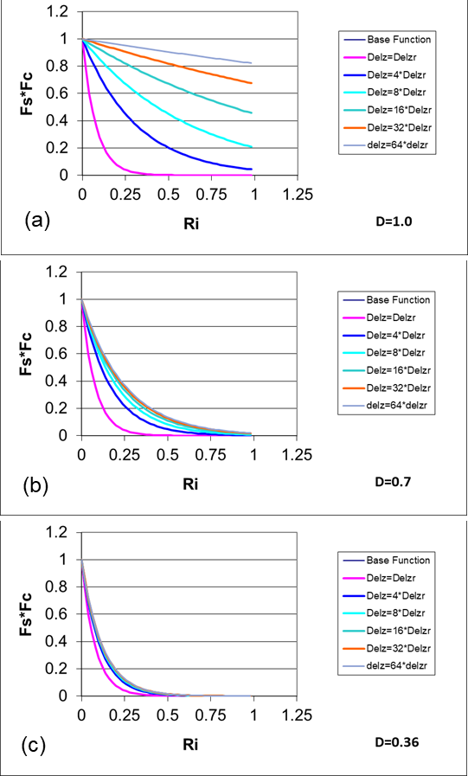
Fig. 6. Behavior of the correction function (actually fs*fc) from (8) as a function of Ri for different values of D. Note that for a smaller $∆z$ the correction yields a short tail form, and for a larger $∆z$ yields a longer tail form with greater mixing. Note that the base function is covered by the delZr case.

- Preliminary Tests of the Analytically Derived Correction Function
In order to test the correction function in (8), we carry out a series of numerical simulations for the Arctic using the UAH single column model (see Figure 5) discussed in McN12. Note that the UAH model uses an explicit diffusion scheme to avoid numerical diffusion (see MCN12) rather than a semi-implicit scheme used in many operational models. We employ the GABLS1 single-column model inter-comparison framework (see Cuxart et al., 2006), which is based on an idealized Arctic stable boundary layer (Kosovic and Curry, 2000). The initial components of the wind are set equal to those of the geostrophic wind (u=ug, v=vg). The potential temperature (θ) equals 265 K up to 100 m, then it increases at a rate of 0.01 K/m until the domain top (400 m), where a value of 268K is reached. The surface temperature is set to 265 K initially, decreasing at a constant rate of 0.25 K/h. The value of the aerodynamic roughness length (z₀) is set to 0.1 m. Note, this is a very idealized case. Actual Arctic boundary layers may have fine-scale features with more complex and deeper stable atmospheric structure.
In making the runs, we desire to have the surface momentum flux ($u_{*}^{2})$and heat flux ($u_{*}θ_{*}$) consistent with the stability functions used in the atmospheric simulations (Tastula 2015b). Following England and McNider 1995 we define
$u_{*}^{2}=k^{2}f_{m}\left({Ri}_{1/2} \right) |V_{1}|^{2}/ (ln\frac{z_{1}}{z_{0}})$,
$u_{*}θ_{*}=k^{2}f_{h}\left({Ri}_{1/2}\right)\left|V_{1}\right|\left(θ_{1}-θ_{G}\right) /(ln\frac{z_{1}}{z_{0}})$
where k is the Von Karman constant, $V_{1}$ is the first level wind speed, $z_{1}$is the first model level, $z_{0}$ is the surface roughness, $θ_{1}$ is the potential temperature at the first level, $θ_{G}$ is the surface or ground temperature and ${Ri}_{1/2}$ is the gradient Richardson between the $z_{0}$ and $z_{1}.$
Here, we explore the sensitivity of the solutions to grid spacing and then examine whether we can use the correction function in (8) to make the solution more independent of grid vertical resolution. Figure 7 shows the model simulation of potential temperature after 10 hours of simulation for different grid spacings with no correction. Note that the mixing in the coarser grids is less than the values for the 2 m grid. This is consistent with our original formulation for Ri (see (4) above), in that Ri would be larger, indicating a reduction in f_{s}(Ri) (since Ri would be shifted to the right as in Figure 4). The coarser grid also shows the mixing increasing with height, but near the 250 m level, it has slightly less mixing than the finer grids. While the differences in mixing are small, the behavior of the temperature profile is quite different. Showing the sensitive non-linear behavior of the SBL (McNider et al. 1995 and Van de Wiel et al. 2002a,b).
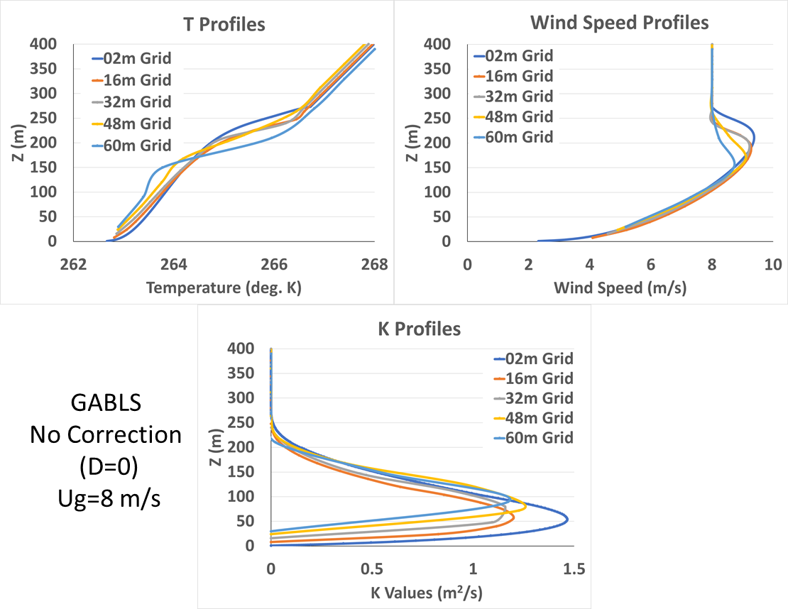
Figure 7 Case for No Correction. (top left) Potential temperature profile after 10 hrs of simulation for different grid spacings. (top right) wind speed profile (m s⁻¹) after 10 hours of simulation for different grid spacings. (bottom) average mixing values over the length of the integration for different grid spacings K (m²s⁻¹). Grid spacings are given in figures.

Here, the differences for different grid spacing may not seem large, but in this idealized limited-height case, the largest grid was only 60 meters. In real Arctic profiles, which may go up to 10-15 km, the GCM grid spacing may be 200 - 500 m or more (Esau and Byrkjedal 2007). As will be discussed later, the GABLS1 case, utilized here, is an extremely idealized barotropic case with no shear in the upper atmosphere, which would exist in real baroclinic cases. The GABLS1 framework, which is well known in the SBL community, is only used as initial proof of concept for our approach. Real cases may show much greater differences as larger grid spacing and more complex profiles are used. There is also the large non-linearity in the SBL, in that small changes in mixing can lead to large changes in the SBL structure (see Mahrt 1989; Derbyshire 1999; McNider et al. 1995; Van de Wiel et al. 2002a,b).
We next employ the grid correction function (8). In interpreting the figures, we are looking for corrections that make the larger grid results more like the 2m or $∆z_{r}$ reference grid. We first tried using D=1, but it produced too much mixing (similar to the Louis profile in Figure 5). Next, we tried smaller values of D. Figure 7 shows the impact of using f_{c} with D = 0.7. It corrects the lower part of the profile but puts too much mixing at the top of the profile. This indicates that D may need to be variable as discussed below. Note that the mixing coefficients are too large over most of the domain compared to the 2 m reference case.
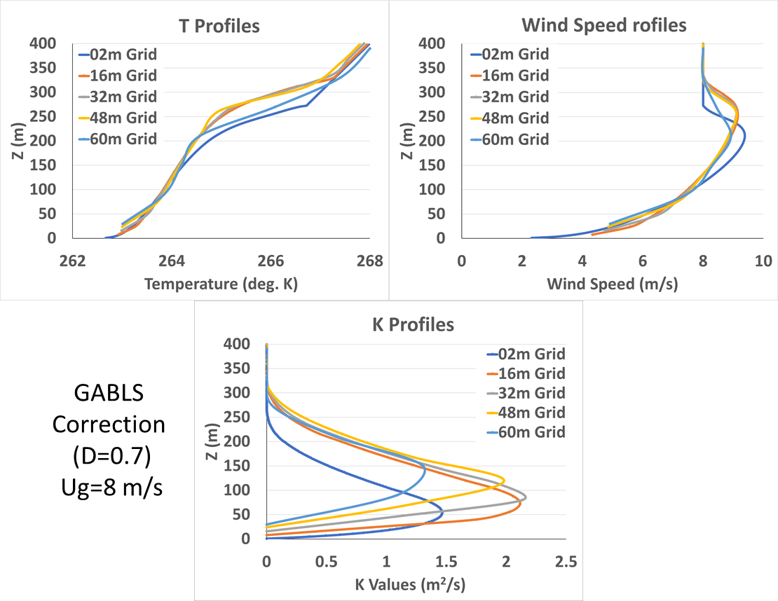
Figure 8 Case for Correction with D = 0.7 (top left) Potential temperature profile after 10 hrs of simulation for different grid spacing. (top right) Wind speed profile (m s ⁻¹ ) after 10 hrs of simulation for different grid spacing. (bottom) Average mixing values over the length of the integration for different grid spacings K (m²s⁻¹). Grid spacings are given in figures.

Figure 9 shows the result with D = 0.36. It shows that the different grids can be corrected to have a solution mostly like the 2m reference case. However, the lower part of the profile correction is not as improved as the D = 0.7 case in Figure 11. Note also in Figure 9 (that the mixing coefficients have been corrected to be more in line with the 2m reference case.

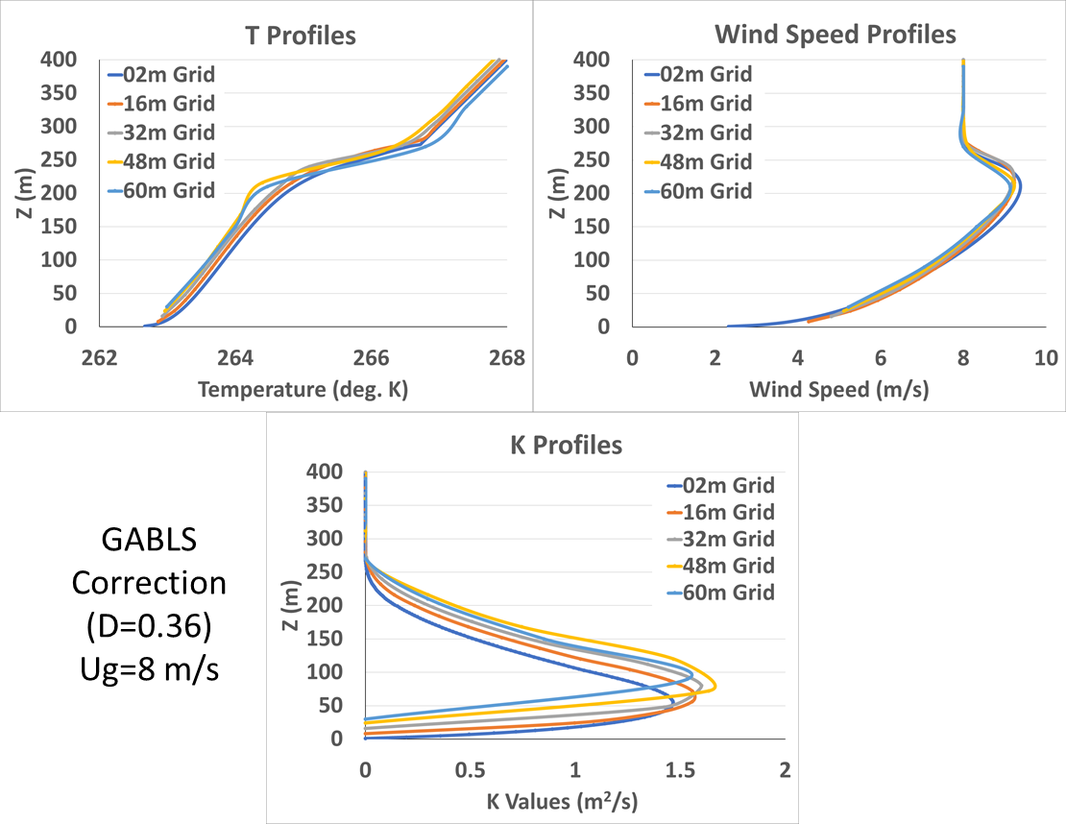
Figure 9 Case for Correction with D= 0.36. (top left) Potential temperature profile after 10 hrs of simulation for different grid spacing. (top right) Wind speed profile (m s⁻¹) after 10 hrs of simulation for different grid spacing. (bottom) Average mixing values over the length of the integration for different grid spacings K (m²s⁻¹). Grid spacings are given in figures.
- Improved Specifications to the Parameter “D” in the Analytical Solution
The analytical correction in equation (8) is appealing because of its structure and computational efficiency. It only takes two additional lines of code - one line to compute f_{c} (8) and one to compute the product f_{s}*f_{c}. The correction, which effectively yields longer-tailed stability functions for larger grids, is based on $\frac{Δθ}{{ΔV}^{2}}$ being a constant, which in effect is for Ri being constant. This is not in general true. The examples in Figures 8 and 9 show that the correction functions can make model predictions less grid dependent. However, it also shows that different values of D can impact the correction. Given the fact that the ODE is ill-posed for linear gradients, it seems that one path might be to make D a function of the curvature in $\frac{Δθ}{{ΔV}^{2}}$ or equivalently Ri (Beljaars 2020). Here we explore D as a function of curvature in Ri, i.e. D (d² ($Ri)$/dz²). Under this proposed framework, D becomes smaller as gradients in Ri become linear.

Figure 10 shows a plot of Ri for the case of “No Correction” given in Figure 7. Note this is the average value of Ri over the length of the integration (10 hours), consistent with the average K values in figures 7-9. Visually, the average curvature (concave upward) is largest below about 40 m, and between 40 m and 90 m, there is less curvature. Near 75 m, the curvature changes sign (concave down). Above 100 m, the curvature becomes less but remains concave downward. Note also that the curvature is smaller in the larger grids.
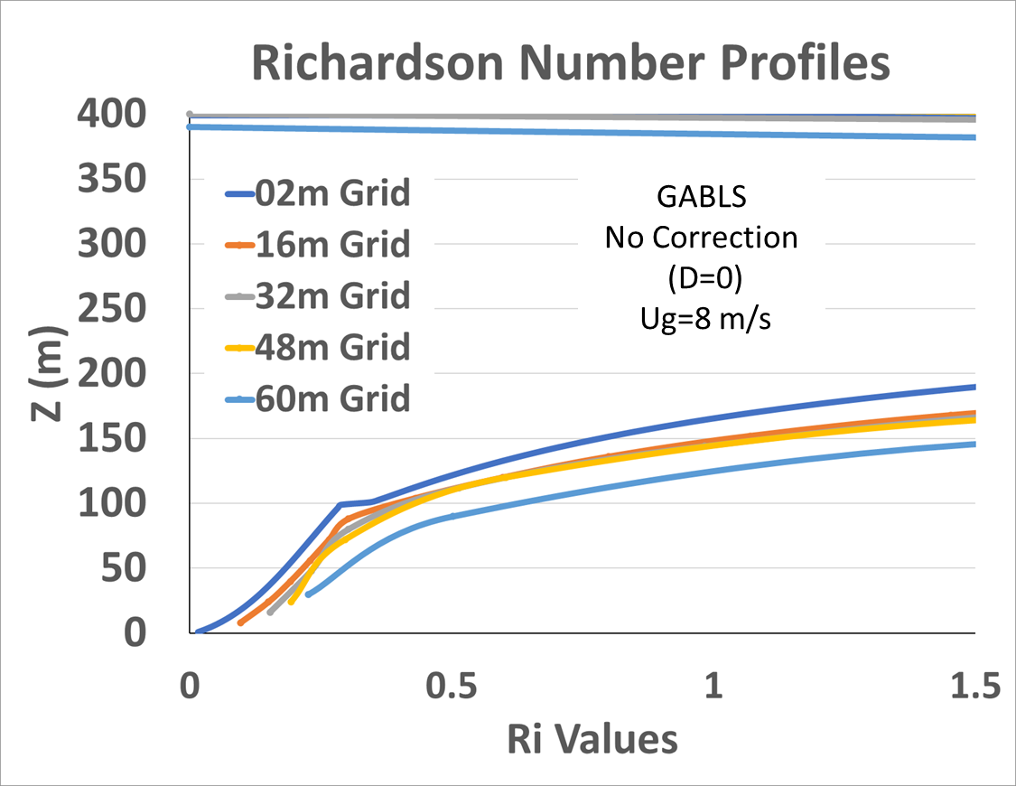
Figure 10 Plot of Ri for the Case of No Correction given in figure 7. These are the average values of Ri over the length of the run (ten hours). Note that curvature (concave upward) is largest below about 40 m. Between 40 m and 90 m there is less curvature. Near 75 m, the curvature changes sign (concave down). Above 100 m the curvature becomes less but remains concave downward. Note also that the curvature is smaller in the larger grids.

As noted above D=0.36 provides a correction which makes the coarser grids look more like the finer grid solution. In adding curvature, we explored D being a linear function of curvature. We used a linear function
D = D₀ + M* |(d² ($Ri)$/dz²|
where D₀ is the intercept (minimum value) and M is the slope. For curvature, d² ($Ri)$/dz², we employ the absolute value of the curvature since the sign of the curvature should not be relevant. Since a value of D=0.36 as seen in Figure 9, provides an improvement, but a value of D = 0.7, as seen in Figure 8, provides too much mixing, we tried linear functions that bracket these values. Specifically, we chose through trials that D₀ = 0.3 and M= 300 so that
D = 0.3 +300 * |(d² ($Ri)$/dz²| with D < 0.7 (11)
provided the best results.
Figure 11 shows the results of this curvature-dependent correction. It shows that the curvature-dependent correction for D (8), is an improvement over D=0.36. The curvature correction improves the upper part of the temperature profile, bringing it in line with the 2m grid case. Near the bottom of the profile, there seems to be a need for further correction. However, in looking at the curvature, as seen in Figure 10, it can be seen that the coarser grids do not capture the amount of curvature as seen in the smaller grids. In these simulations, we used similarity theory (England and McNider 1995) to specify heat and momentum from the surface up to the first model layer. As discussed below, a refinement in the technique in the future could utilize the curvature from surface similarity in terms of Ri rather than the grid-calculated curvature employed here.
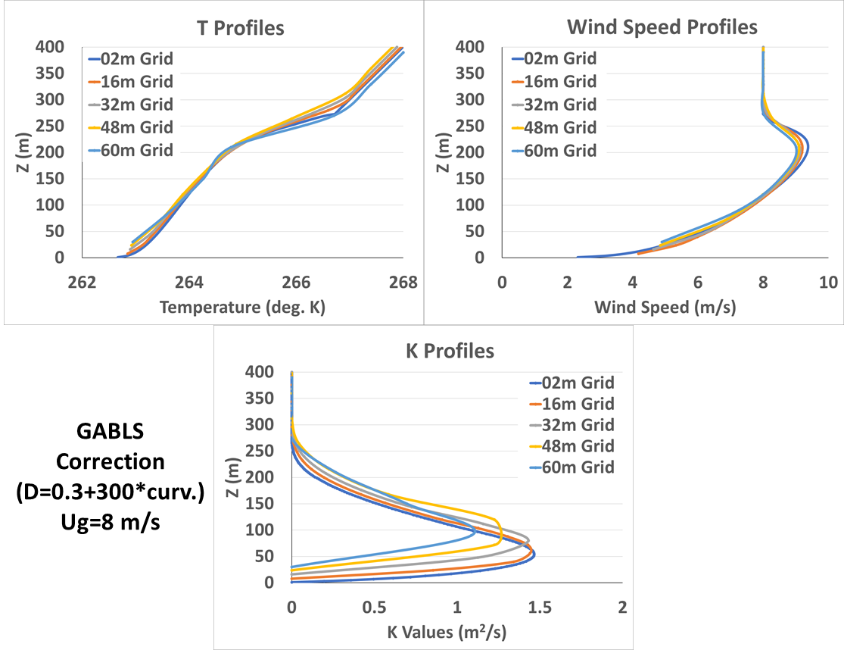
Figure 11 Case for D function of curvature ( 8). (top left) Potential temperature profile after 10 hrs of simulation for different grid spacing. (top right) Wind speed profile (m s⁻¹ ) after 10 hrs of simulation for different grid spacing. (bottom) Average mixing values over the length of the integration for different grid spacings K (m²s⁻¹). Grid spacings are given in figures.

- Additional Tests of the Value of D
While the improvements with the curvature-dependent D above look promising in Figure 11, there is concern that the values used in equation (11) may not work well in other cases
We have added 10 additional cases (6 wind speeds, 2 cooling rates and 2 roughness values) to test the robustness of the curvature dependent D. These are all within the framework of the GABLS1 physical domain. The reason for maintaining GABLS1 is that this framework was designed to test different boundary layer closure models and different LES models. GABLS1 was also defined around an Arctic setting. It was meant to test how different turbulence closures embedded in weather forecast models or LES simulations would change temperature and wind profiles. Thus, issues such as different models having different surface models were eliminated by having a specified surface cooling rate.
Since in this paper we are looking specifically at how the turbulent closure impacts the temperature and wind vertical profiles at different grid spacing, the general GABLS1 framework should be adequate. The GABLS1 base case above was defined with a geostrophic wind of 8 m/s, a surface cooling rate of 0.25 K/h and roughness length of 0.1m. However, within the general framework of fixed initial conditions, there can be different wind speeds, cooling rates and roughness. These are the fundamental parameters that impact boundary layer structure. Here, we carry out 6 different cases where wind speeds are changed from 4 m/s to 10 m/s, 2 cases where cooling rates are changed from 0.25 to 0.5 K/h and two cases where roughness was increased from 0.1 m to 0.5 m. These cases cross the thresholds of very stable boundary layers to weakly stable boundary layers. We believe the additional wind speeds\, cooling rate and roughness cases largely encompass the parameters that impact SBL behavior (see McNider et al. 1995).
Figure 12 shows the first of the new cases with a geostrophic wind of 4 m/s. The figure shows both the uncorrected and corrected profiles. For this low wind speed case, the solution goes to a very stable boundary layer with little to no mixing. There is very little variation for different grid spacings, so there is not much to correct. These very stable cases have always been a challenge since there is little to no turbulence generated by shear. In the real-world, non-MOST phenomena, such as gravity waves, can contribute to mixing (Galperin et al. 2007a).
The following figures 13 – 20 show the other different wind speed cases. Figure 13 for 5 m/s geostrophic wind is similar to the 4 m/s case, but with a bit more mixing. The correction does make some impact to bring the gridded solutions closer together.
Figure 14 shows the case for 6 m/s. Here, the SBL is transitioning from a very stable state to a weakly stable state. There is a greater spread between the grid cases, and we are in the regime where resolution can make a difference, as in the base GABLS1 8 m/s case given in Figure 11. The correction does bring the different grid solutions closer together, especially aloft.
Figure 15 shows the case for 7 m/s, which is close to the GABLS base 8 m/s case. The correction behavior is similar to that of the base case. Figure 16 shows the 9 m/s case and shows a deeper boundary layer. The correction appears to work well here, especially aloft. Finally, Figure 17 shows the 10 m/s case, which yields an even deeper boundary layer. The correction brings the grid cases closer together.

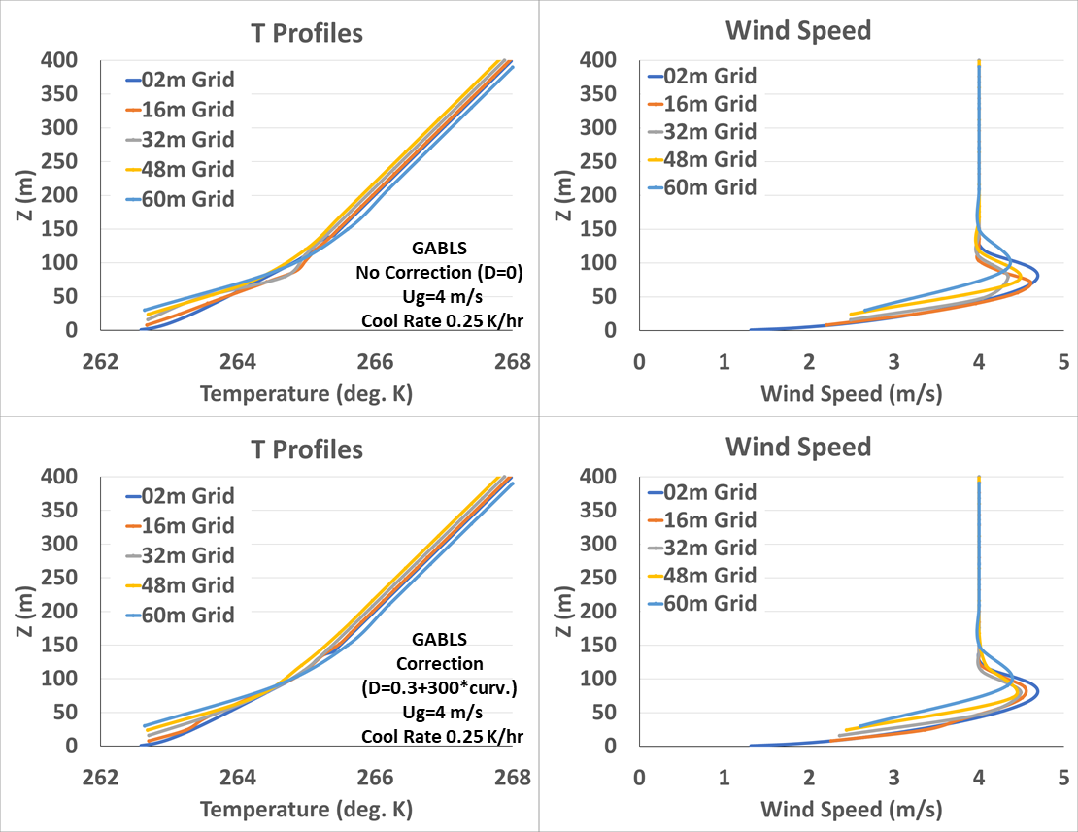
Figure 12 Plots of temperature and wind speed profiles for geostrophic wind speed of 4 m/s and cooling rate of 0.25 K/hr. Top uncorrected and bottom corrected using D in (8).

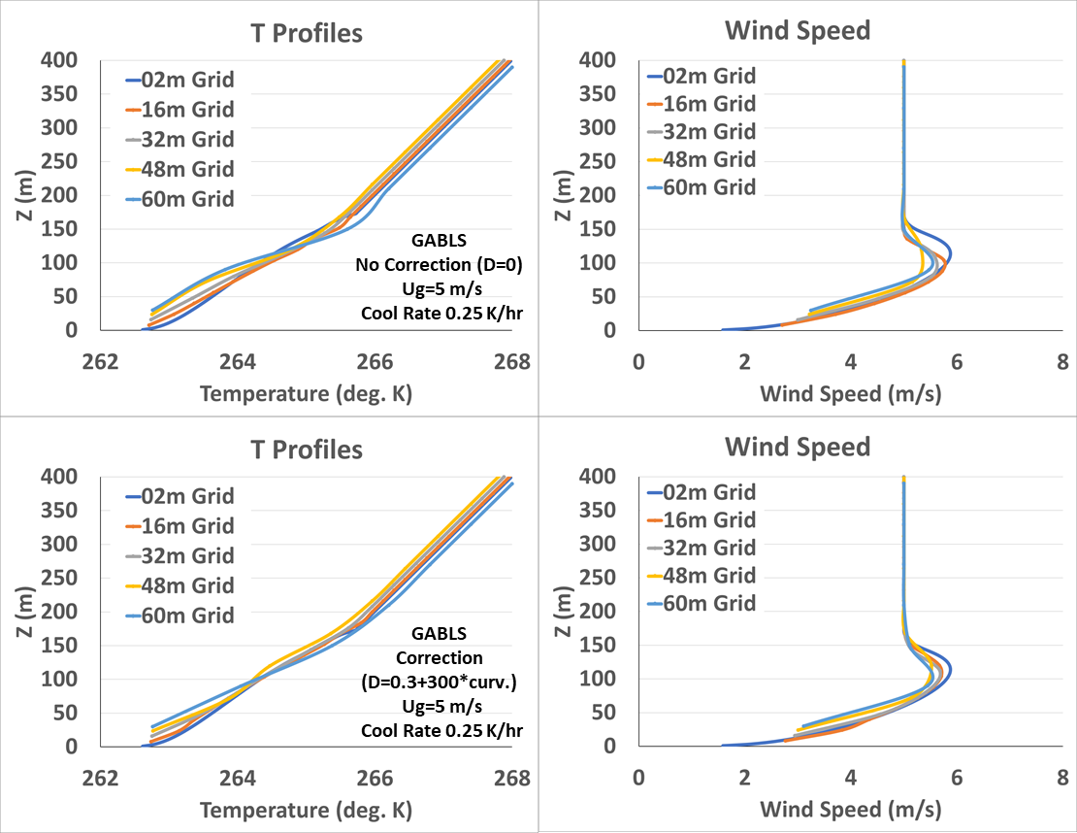
Figure 13 Plots of temperature and wind speed profiles for geostrophic wind speed of 5 m/s and cooling rate of 0.25 K/hr. Top uncorrected and bottom corrected using D in (8)

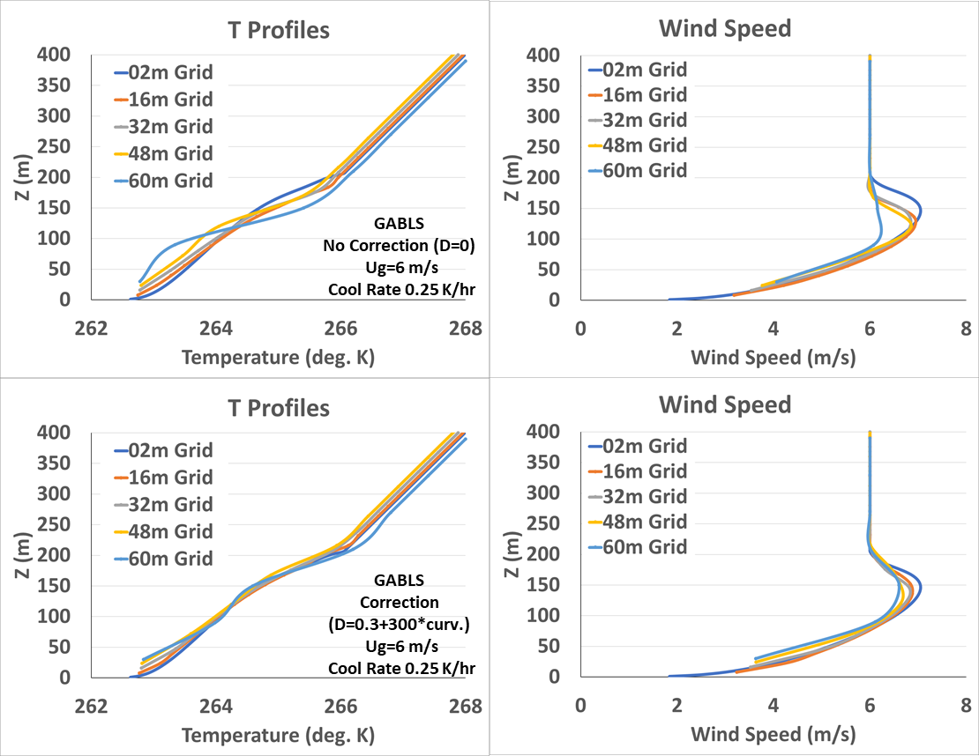
Figure 14 Plots of temperature and wind speed profiles for geostrophic wind speed of 6 m/s and cooling rate of 0.25 K/hr. Top uncorrected and bottom corrected using D in (8)
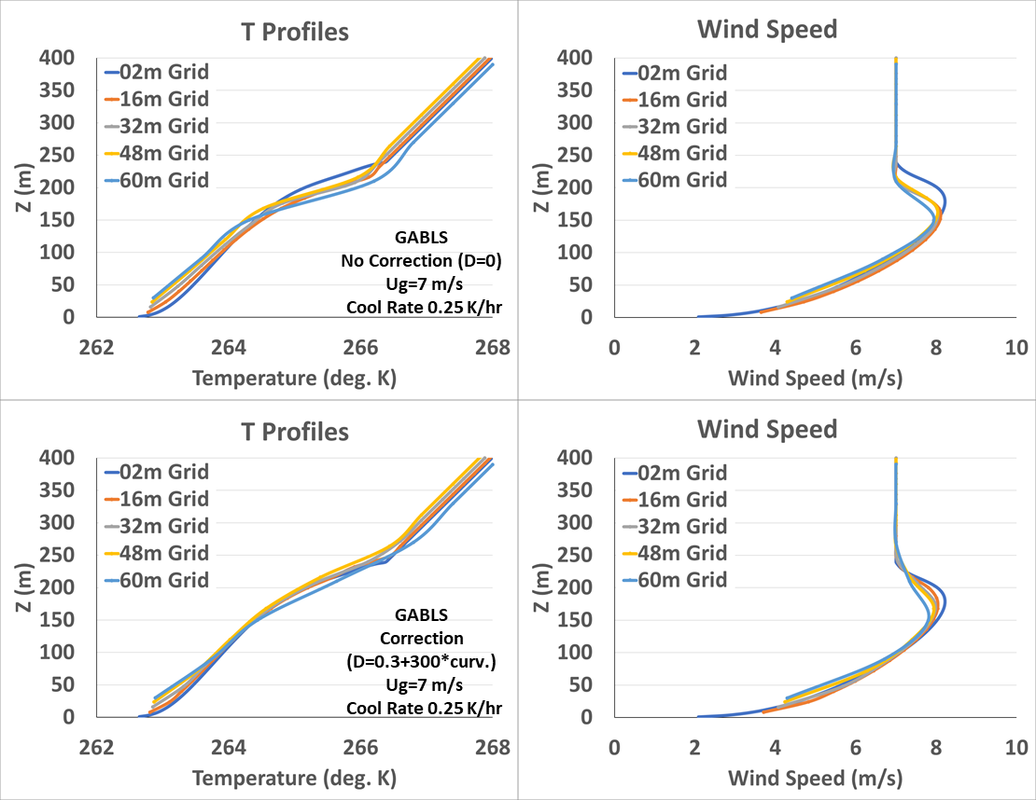
Figure 15 Plots of temperature and wind speed profiles for geostrophic wind speed of 7 m/s and cooling rate of 0.25 K/hr. Top uncorrected and bottom corrected using D in (8)

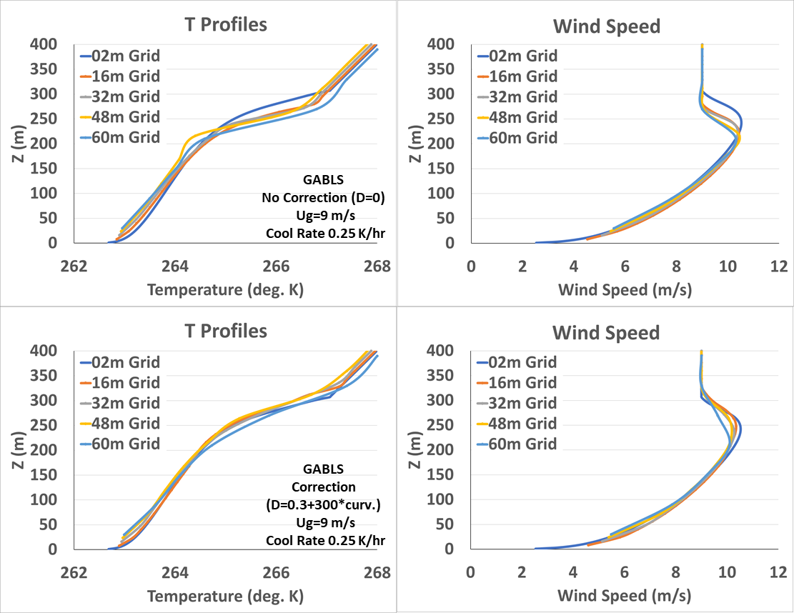
Figure 16 Plots of temperature and wind speed profiles for geostrophic wind speed of 9 m/s and cooling rate of 0.25 K/hr. Top uncorrected and bottom corrected using D in (8)

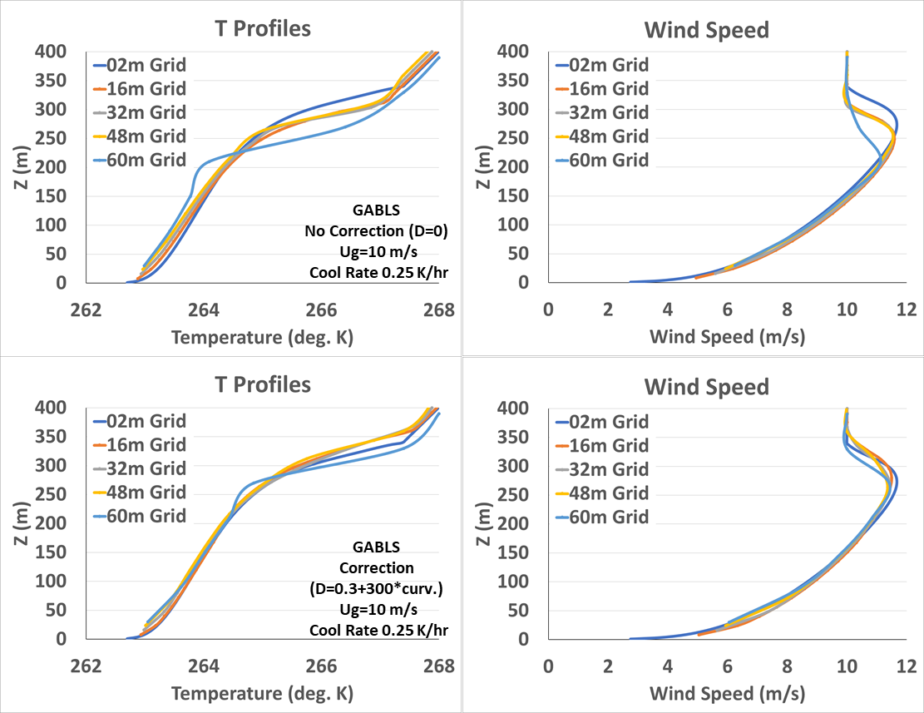
Figure 17 Plots of temperature and wind speed profiles for geostrophic wind speed of 10 m/s and cooling rate of 0.25 K/hr. Top uncorrected and bottom corrected using D in (8)

The analytical correction with the D curvature correction tested for different geostrophic wind speeds appears to work nearly well as it did for the 8 m/s case, from which it was derived. To quantify the impact of the corrections, we examined, for temperature and wind speed, the departure of the different grid values from the 2m values (which in this case would be considered the best or truth). We picked the closest 2m grid to the corresponding coarse grid level. We only made comparisons for the temperature and wind speeds, which were in the turbulent boundary layer. Since outside the boundary layer, the wind and temperature show little to no difference from the initial specified profiles. The results are presented in Figures 18 and 19. The term All Data means that the data values for all the cases in Figures 12-17 were compared to those of the 8 m/s case from which the D parameter was developed. Some of the differences in the statistics perhaps come from the boundary layer depth approximation which we used to determine where to make the difference calculations. Also, the two low wind speed cases did not show as much improvement. These very stable cases have always been difficult for models.
We also changed the cooling rates and surface roughness to evaluate the corrections. The cooling rate cases were not much different in behavior and correction than the wind speed cases. We increased the cooling rate from 0.25 K/ hr to 0.5 K/ hr. The results seemed equivalent to lowering the wind speed in the cases above. The roughness was increased from 10 cm (the GABLS1 default) to 50 cm. The roughness cases also seemed to have a similar correction. Since there was not much difference in their behavior, we include these plots in Appendix B. We didn’t try to quantify the correction as in figures 18-19 in part because we only had two cases each. Also, the boundary depth was different than the values we estimated for the different wind speeds for the GABLS1 roughness and cooling rates. We used boundary layer depth to determine where to make the difference calculations.

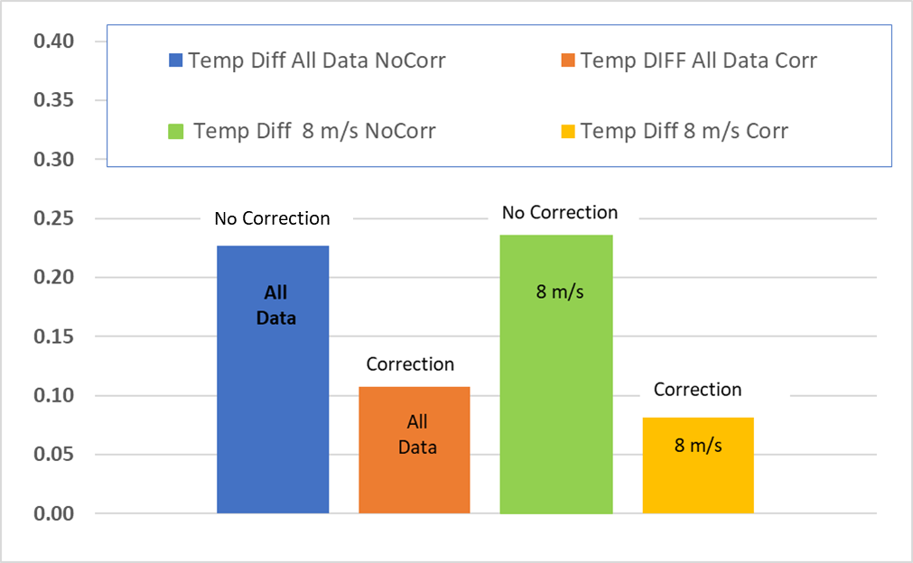
Figure 18 Plot showing mean differences between grid values of temperature (all levels) and 2m grid (closest level) values. For All Data and the 8 m/s case.

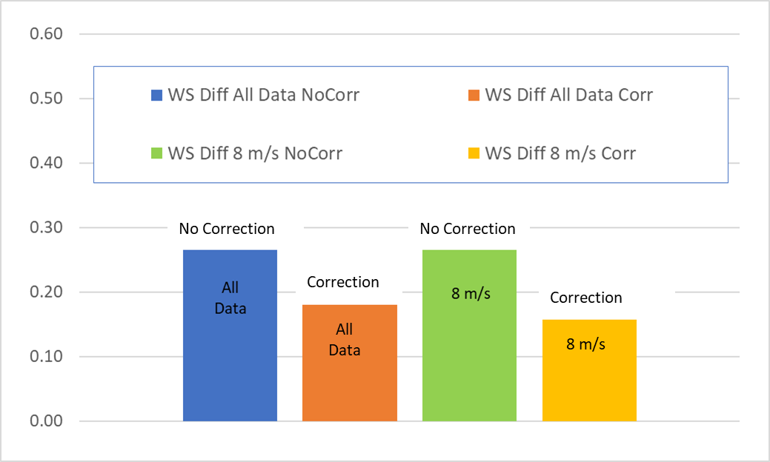
Figure 19 Plot showing mean differences between grid values of wind speed (all levels) and 2m grid (closest level) values. For All Data and the 8 m/s case.

4 Summary and Conclusions
The background on Arctic Amplification (AA) and the modeling of the SBL in coarse grid climate models suggests that treatments of the SBL and deeper SL in GCMs may be partly responsible for the spread seen in GCM predictions in high latitudes. This may also be part of the reason models have underestimated the strength of AA. As discussed in section 2., if models have too much mixing in the base-state, they may not have the sensitivity to enhanced GHG energy as models with less mixing. Also, given the difficulties with handling the SBL and SL in coarse grid settings, GCMs may have other fixes that add mixing and underestimate the sensitivity to GHG energy.
The present study provides a quantitative approach to correcting model performance in predicting local turbulent levels in stable environments with different vertical grid spacings. As discussed in Section 3, this has long been a problem for models using local closures, in that coarser grid operational models had too little mixing. Modelers such as Louis 1979, McNider and Pielke 1981, Beljaars and Holtslag 1991, and Viterbo and Beljaars 1995 added additional mixing through either longer-tailed stability functions (f_{s}) or larger critical Richardson numbers.
The present study provides an analytical framework for defining a correction function (f_{c}) for the stability functions such that $\frac{d}{d∆z}(f_{s}\left(Ri\right)f_{c}\left(Ri,∆z\right))=0$. This ODE was solved analytically under certain assumptions to recover $f_{c}\left(Ri,∆z\right)$. These correction functions were tested in a simplified Arctic simulation framework GABLS1 (Cuxart et al. 2006) and found to make the solutions less grid dependent. However, the assumptions that allowed the analytical solution generally are not met. A more robust path may be the numerical solution of the ODE $\frac{d}{d∆z}(f_{s}\left(Ri\right)f_{c}\left(Ri,∆z\right))=0$. This path is discussed in Appendix A.
In terms of Arctic Amplification, it is an extraordinarily complex system involving albedo, sea ice and clouds. However, we believe it will be better to evaluate these issues in a system where turbulence and grid dependence, which are also important, were handled as correctly as possible. However, more work and testing are needed. Possible paths for improvements and additional testing are found in Appendix A. It is hoped that this preliminary study can spur new ideas and approaches by others.

Acknowledgments.
This work was sponsored by the Department of Energy grant #DE-SC0023332 with partial support by the Alabama Office of State Climatologist. The article does not necessarily represent views of DOE.

Data Availability Statement.
The model runs and code for the simulations by the UAH model (McNider et al. 2012) can be found on the UAH public server https://drive.google.com/drive/folders/1rQLdJeHbTV5kjyylgo5AFXk6Ss-mQlSm?usp=sharing

REFERENCES
Acevedo, O.C., Costa, F.D., Maroneze, R., Carvalho, A.D., Puhales, F.S. and Oliveira, P.E., 2021: External controls on the transition between stable boundary‐layer turbulence regimes. Quarterly Journal of the Royal Meteorological Society, 147(737), 2335-2351, https://doi.org/10.1002/qj.4027.
Audouin, O., Roehrig, R., Couvreux, F. and Williamson, D., 2021: Modeling the GABLS4 Strongly‐Stable Boundary Layer With a GCM Turbulence Parameterization: Parametric Sensitivity or Intrinsic Limits? Journal of Advances in Modeling Earth Systems, 13(3), e2020MS002269, https://doi.org/10.1029/2020MS002269.
Basu, S., Raman, S., Mohanty, U.C. and Rajagopal, E.N., 1999: Influence of the planetary boundary layer physics on medium-range prediction of monsoon over India. pure and applied geophysics, 155, pp.33-55, https://doi.org/10.1007/s000240050253.
Beljaars, A.C.M. and Holtslag, A.A.M., 1991: Flux parameterization over land surfaces for atmospheric models. Journal of Applied Meteorology, 30(3), 327-341, https://doi.org/10.1175/1520-0450(1991)030<0327:FPOLSF>2.0.CO;2.
Beljaars, A.C.M. , 2020: Personal Communication.
Beljaars, A. C. M., and Coauthors, 2012: The stable boundary layer in the ECMWF model. Proc. ECMWF Workshop on Diurnal Cycles and the Stable Boundary Layer, Reading, England, ECMWF/WCRP, 1-10, https://www.ecmwf.int/sites/default/files/elibrary/2012/8029-stable-boundary-layer-ecmwf-model.pdf
Bindoff, N.L., Stott, P.A., AchutaRao, K.M., Allen, M.R., Gillett, N., Gutzler, D., Hansingo, K., Hegerl, G., Hu, Y., Jain, S. and Sebbari, R., 2014: Detection and attribution of climate change: from global to regional. Climate change 2013: the physical science basis,
Bintanja, R., Van der Linden, E.C. and Hazeleger, W., 2012: Boundary layer stability and Arctic climate change: A feedback study using EC-Earth. Climate dynamics, 39(11), 2659-2673, https://doi.org/10.1007/s00382-011-1272-1.
Blackadar, A.K., 1979: High resolution models of the planetary boundary layer. Advances in Environmental Science and Engineering, 1(1), 50-85.
Beare, R.J., Macvean, M.K., Holtslag, A.A., Cuxart, J., Esau, I., Golaz, J.C., Jimenez, M.A., Khairoutdinov, M., Kosovic, B., Lewellen, D. and Lund, T.S., 2006. An intercomparison of large-eddy simulations of the stable boundary layer. Boundary-Layer Meteorology, 118(2), pp.247-272.
Boe, J., Hall, A. and Qu, X., 2009: Current GCMs’ unrealistic negative feedback in the Arctic. Journal of Climate, 22(17), 4682-4695, https://doi.org/10.1175/2009JCLI2885.1.
Boeke, R.C., Taylor, P.C. and Sejas, S.A., 2021. On the nature of the Arctic's positive lapse‐rate feedback. Geophysical Research Letters, 48(1), p.e2020GL091109.
Businger JA, 1973: Turbulent transfer in the atmospheric surface layer. In Workshop on Micrometeorology, 67-100, Am. Met. Soc.
Byrkjedal, Ø., Esau, I. and Kvamstø, N.G., 2008: Sensitivity of simulated wintertime Arctic atmosphere to vertical resolution in the ARPEGE/IFS model. Climate dynamics, 30(7-8), 687-701, https://doi.org/10.1007/s00382-007-0316-z.
Cai, M., and J. H. Lu, 2007: Dynamical greenhouse-plus feedback and polar warming amplification. Part II: Meridional and vertical asymmetries of the global warming. Climate Dyn., 29, 375–391, https://doi.org/10.1007/s00382-007-0238-9.
Cai, Z. et al. , 2021a: Arctic warming revealed by multiple CMIP6 models: evaluation
of historical simulations and quantification of future projection uncertainties.
J. Clim. 34, 4871–4892.
Cai, S., Hsu, P.-C., and Liu, F., 2021b: Changes in Polar Amplification in Response
to Increasing Warming in CMIP6. Atmos. Oceanic Sci. Lett. 14, 100043–102834.
doi:10.1016/j.aosl.2021.100043
Casasanta, G., Conte, M., Sozzi, R., Cecilia, A., Petenko, I. and Argentini, S., 2025. Towards definitive functional forms for Monin–Obukhov similarity functions in stable and very stable surface layers. Scientific Reports, 15(1), p.25632.
Cuxart, J., Holtslag, A. A. M., Beare, R. J., Bazile, E., Beljaars, A., Cheng, A., Conangla, L., Freedman, M. Ek, F. , Hamdi, R., Kerstein, A., Kitagawa, H., Lenderink, G., Lewellen, D., Mailhot, J., Mauritsen, T., Perov, V., Schayes, G., Steeneveld, G. J. Svensson, G., Taylor, P., Weng, W., Wunsch, S. and Xu, K.-M., 2006: Single Column Model Intercomparison for the Stably Stratified Atmospheric Boundary Layer, Boundary-Layer Meteorol., 118(2), 273-303, https://doi.org/0.1007/s10546-005-3780-1.
Davy, R. and Esau, I., 2014: Global climate models’ bias in surface temperature trends and variability. Environmental Research Letters, 9(11), 114024, https://doi.org/10.1088/1748-9326/9/11/114024.
Davy, R. and Outten, S., 2020: The Arctic surface climate in CMIP6: status and developments since CMIP5. Journal of Climate, 33(18), 8047-8068, https://doi.org/10.1175/JCLI-D-19-0990.1.
Derbyshire, S.H., 1999: Boundary-layer decoupling over cold surfaces as a physical boundary-instability. Boundary-Layer Meteorology, 90(2), 297-325.
Dong, H., Zhang, Y., Tao, T., Du, X., Zou, Y. and Cao, S., 2025. Sensitivity of near-ground wind to PBL schemes, reanalysis data, and nudging in month-long WRF simulations in the Tibetan Plateau with highly complex terrain. Atmospheric Research, 323, p.108161.
Duynkerke, P.G., 1991: Radiation fog: A comparison of model simulation with detailed observations. Monthly Weather Review, 119(2), 324-341, https://doi.org/10.1175/1520-0493(1991)119<0324:RFACOM>2.0.CO;2.
England, D.E. and McNider, R.T., 1995: Stability functions based upon shear functions. Boundary-Layer Meteorology, 74(1-2), 113-130.
Esau, I.N. and Byrkjedal, Ø., 2007: Application of a large-eddy simulation database to optimisation of first-order closures for neutral and stably stratified boundary layers. Boundary-layer meteorology, 125(2), 207-225.
Fernando, H.J.S. and Weil, J.C., 2010: Whither the stable boundary layer? A shift in the research agenda. Bulletin of the American Meteorological Society, 91(11), 1475-1484.
Franzke, C.L., Lee, S. and Feldstein, S.B., 2017: Evaluating Arctic warming mechanisms in CMIP5 models. Climate Dynamics, 48, 3247-3260.
Galperin, B., Sukoriansky, S. and Anderson, P.S., 2007a. On the critical Richardson number in stably stratified turbulence. Atmospheric Science Letters, 8(3), pp.65-69.
Galperin, B., Sukoriansky, S. and Perov, V., 2007b: Implementation of the quasi-normal scale elimination (QNSE) turbulence model in WRF. In The Eighth WRF Users’ Workshop.https://www2.mmm.ucar.edu/wrf/users/workshops/WS2007/presentation/5-6_Galperin.pdf
Graversen, R.G. and Wang, M., 2009: Polar amplification in a coupled climate model with locked albedo. Climate Dynamics, 33, 629-643.
Hahn, L.C., Armour, K.C., Zelinka, M.D., Bitz, C.M. and Donohoe, A., 2021. Contributions to polar amplification in CMIP5 and CMIP6 models. Frontiers in Earth Science, 9, p.710036.
Hall, A., 2004: The role of surface albedo feedback in climate. Journal of Climate, 17(7), 1550-1568.
Holtslag, A.A.M. and Boville, B.A., 1993: Local versus nonlocal boundary-layer diffusion in a global climate model. Journal of Climate, 6(10), 1825-1842.
Janjic ZI. 2001: Nonsingular implementation of the Mellor-Yamada Level 2.5 scheme in the NCEP Meso Model, NOAA/NWS/NCEP Office Note 437.
Kantha, L.H. and Clayson, C.A., 1994: An improved mixed layer model for geophysical applications. Journal of Geophysical Research: Oceans, 99(C12), 25235-25266.
Kosović, B. and Curry, J.A., 2000: A large eddy simulation study of a quasi-steady, stably stratified atmospheric boundary layer. Journal of the atmospheric sciences, 57(8), 1052-1068
Louis, J.F., 1979: A parametric model of vertical eddy fluxes in the atmosphere. Boundary-Layer Meteorology, 17(2), 187-202.
Mahrt, L., 1989: Limit cycle mixing. Journal of Atmospheric Sciences, 46(8), 1061-1075.
Mahrt, L., 1996: The bulk aerodynamic formulation over heterogeneous surfaces. Boundary-Layer Meteorology, 78(1), 87-119.
Manabe, S. and Stouffer, R.J., 1994: Multiple-century response of a coupled ocean-atmosphere model to an increase of atmospheric carbon dioxide. Journal of climate, 7(1), 5-23.
Manabe, S. and Wetherald, R.T., 1975: The effects of doubling the CO2 concentration on the climate of a general circulation model. Journal of Atmospheric Sciences, 32(1), 3-15.
McNider, R.T. and Pielke, R.A., 1981: Diurnal boundary-layer development over sloping terrain. Journal of Atmospheric Sciences, 38(10), 2198-2212.
McNider, R.T., England, D.E., Friedman, M.J. and Shi, X., 1995: Predictability of the stable atmospheric boundary layer. Journal of the Atmospheric Sciences, 52(10), 1602-1614.
McNider, R.T., Pour-Biazar, A., Doty, K., White, A., Wu, Y., Qin, M., Hu, Y., Odman, T., Cleary, P., Knipping, E. and Dornblaser, B., 2018: Examination of the physical atmosphere in the Great Lakes region and its potential impact on air quality—Overwater stability and satellite assimilation. Journal of Applied Meteorology and Climatology, 57(12), 2789-2816.
McNider, R.T., Steeneveld, G.J., Holtslag, A.A.M., Pielke, R.A., Mackaro, S., Pour‐Biazar, A., Walters, J., Nair, U. and Christy, J., 2012: Response and sensitivity of the nocturnal boundary layer over land to added longwave radiative forcing. Journal of Geophysical Research: Atmospheres, 117(D14).

Mellor, G. L., 1973: Analytic prediction of the properties of stratified planetary surface layers. J. Atmos. Sci., 30, 1061-1069.
Mellor, G.L. and Yamada, T., 1982: Development of a turbulence closure model for geophysical fluid problems. Reviews of Geophysics, 20(4), 851-875.
Nielsen-Englyst, P., Høyer, J.L., Kolbe, W.M., Dybkjær, G., Lavergne, T., Tonboe, R.T., Skarpalezos, S. and Karagali, I., 2023. A combined sea and sea-ice surface temperature climate dataset of the Arctic, 1982–2021. Remote Sensing of Environment, 284, p.113331.
Pithan, F. and Mauritsen, T., 2014: Arctic amplification dominated by temperature feedbacks in contemporary climate models. Nature Geoscience, 7(3), 181.
Pithan, F., Ackerman, A., Angevine, W.M., Hartung, K., Ickes, L., Kelley, M., Medeiros, B., Sandu, I., Steeneveld, G.J., Sterk, H.A. and Svensson, G., 2016: Select strengths and biases of models in representing the Arctic winter boundary layer over sea ice: the Larcform 1 single column model intercomparison. Journal of advances in modeling earth systems, 8(3), 1345-1357.
Pleim, J.E., 2007: A combined local and nonlocal closure model for the atmospheric boundary layer. Part I: Model description and testing. Journal of Applied Meteorology and Climatology, 46(9), 1383-1395.
Savijärvi, H., 2009: Stable boundary layer: Parametrizations for local and larger scales. Quarterly Journal of the Royal Meteorological Society, 135(641), 914-921.
Screen, J.A., Deser, C. and Simmonds, I., 2012: Local and remote controls on observed Arctic warming. Geophysical Research Letters, 39(10).
Shir, C.C. and Bornstein, R.D., 1977: Eddy exchange coefficients in numerical models of the planetary boundary layer. Boundary-Layer Meteorology, 11(2), 171-185.
Sukoriansky, S., Galperin, B. and Perov, V., 2005. Application of a new spectral theory of stably stratified turbulence to the atmospheric boundary layer over sea ice. Boundary-layer meteorology, 117(2), pp.231-257.
Steeneveld, G.J., Mauritsen, T., De Bruijn, E.I.F., Vilà-Guerau de Arellano, J., Svensson, G. and Holtslag, A.A.M., 2008a: Evaluation of limited-area models for the representation of the diurnal cycle and contrasting nights in CASES-99. Journal of Applied Meteorology and Climatology, 47(3), 869-887.

Steeneveld, G.J., Holtslag, A.A.M., Nappo, C.J., Van de Wiel, B.J.H. and Mahrt, L., 2008b: Exploring the possible role of small-scale terrain drag on stable boundary layers over land. Journal of applied meteorology and climatology, 47(10), 2518-2530.
Steeneveld, G.J., Van de Wiel, B.J.H. and Holtslag, A.A.M., 2006: Modeling the evolution of the atmospheric boundary layer coupled to the land surface for three contrasting nights in CASES-99. Journal of the atmospheric sciences, 63(3), 920-935.
Stull, R.B., 1988: Mean boundary layer characteristics. In An introduction to boundary layer meteorology (pp. 1-27). Dordrecht: Springer Netherlands.
Sukoriansky, S., Galperin, B. and Staroselsky, I., 2005: A quasinormal scale elimination model of turbulent flows with stable stratification. Physics of fluids, 17(8), 085107.
Sukoriansky, S., 2008: Implementation of the Quasi-Normal Scale Elimination (QNSE) model of stably stratified turbulence in WRF. Report on WRF-DTC Visit of Semion Sukoriansky, June 2008.

Swanson, K.L., 2013: Emerging selection bias in large‐scale climate change simulations. Geophysical Research Letters, 40(12), 3184-3188.
Tastula, E.M., Galperin, B., Dudhia, J., LeMone, M.A., Sukoriansky, S. and Vihma, T., 2015a: Methodical assessment of the differences between the QNSE and MYJ PBL schemes for stable conditions. Quarterly Journal of the Royal Meteorological Society, 141(691), 2077-2089.
Tastula, E.M., Galperin, B., Sukoriansky, S., Luhar, A. and Anderson, P., 2015b. The importance of surface layer parameterization in modeling of stable atmospheric boundary layers. Atmospheric Science Letters, 16(1), pp.83-88.
Taylor, P.C., Cai, M., Hu, A., Meehl, J., Washington, W. and Zhang, G.J., 2013: A decomposition of feedback contributions to polar warming amplification. Journal of Climate, 26(18), 7023-7043.
Van de Wiel, B. J. H., A. F. Moene, R.J. Ronda H. A. R. De Bruin, and A. A. M. Holtslag, 2002b: Intermittent turbulence and oscillations in the stable boundary layer over land. Part II. A system dynamics approach., J. Atmos. Sci., 59, 2567-2581.
Van de Wiel, B. J. H., Moene, A. F., Jonker, H. J. J., Baas, P., Basu, S., Donda, J. M. M., . . . Holtslag, A. A. M., 2012: The minimum wind speed for sustainable turbulence in the nocturnal boundary layer. Journal of Atmospheric Science, 69, 3097–3115, https://doi.org/10.1175/JASD-12-064.1.
van de Wiel, B. J. H., Vignon, E., Baas, P., van Hooijdonk, I. G. S., van der Linden, S. J. A., van Hooft, J. A., . . . Genthon, C., 2017: Regime transitionin near-surface temperature inversions: A conceptual model. Journal of Atmospheric Sciences, 74, 1057–1073, https://doi.org/10.1175/JAS-D-16-0180.1.
Van de Wiel, B.J.H., Ronda, R.J., Moene, A.F., De Bruin, H.A.R. and Holtslag, A.A.M., 2002: Intermittent turbulence and oscillations in the stable boundary layer over land. Part I: A bulk model. Journal of the Atmospheric Sciences, 59(5), 942-958.
Vignon, E., van de Wiel, B.J., van Hooijdonk, I.G., Genthon, C., van der Linden, S.J., van Hooft, J.A., Baas, P., Maurel, W., Traullé, O. and Casasanta, G., 2017: Stable boundary‐layer regimes at Dome C, Antarctica: observation and analysis. Quarterly Journal of the Royal Meteorological Society, 143(704), 1241-1253.
Viterbo, P. and Beljaars, A.C., 1995: An improved land surface parameterization scheme in the ECMWF model and its validation. Journal of climate, 8(11), 2716-2748.
, P., Beljaars, A., Mahfouf, J.F. and Teixeira, J., 1999: The representation of soil moisture freezing and its impact on the stable boundary layer. Quarterly Journal of the Royal Meteorological Society, 125(559), 2401-2426.
Walters, J. T., R. T. McNider, X. Shi, and W. B. Norris, 2007: Positive surface temperature feedback in the stable nocturnal boundary layer. Geophys. Res. Let., 34(12), https://doi.org/10.1029/2007GL029505.
Wang, Q., Zeng, B., Chen, G. and Li, Y., 2024. Simulation performance of different planetary boundary layer schemes in WRF V4. 3.1 on wind field over Sichuan Basin within" Gray zone" resolution. EGUsphere, 2024, pp.1-25.
Zilitinkevich, S.S. and Esau, I.N., 2003: The effect of baroclinicity on the equilibrium depth of neutral and stable planetary boundary layers. Quarterly Journal of the Royal Meteorological Society, 129(595), 3339-3356, https://doi.org/10.1256/qj.02.94.

Appendix A
We believe that the development of a grid correction, as presented in the initial tests here, shows promise in improving the problem of grid dependence in modeling the SBL and SL. This may provide a path to allow coarse grid models to make improved climate predictions in the Arctic. However, the initial results show that further improvements are needed in making the analytical adjustment perform better. Also, the simple Arctic simulation carried out here with such a limited vertical domain needs to be expanded to more realistic settings where grid spacing in models may be much greater. As a final caveat, we note that the approach presented here only addresses the explicit dependence of Ri on $∆z$ (4). It does not address issues of unresolved structure (Blackadar, 1979) or mesoscale energy (Mahrt 1996; Steeneveld et al 2008b), which may add mixing.
We hope to carry out future model experiments to look at specifying better correction functions and more realistic settings. However, because of our team’s lack of experience with full climate models, we feel publishing these preliminary results can perhaps allow other investigators to make progress in making the modeling SL in Arctic environments less grid-dependent. We outline some paths for improvement below.
  - Numerical Solutions to Find Correction (f_{c})
The analytical solution derived and tested here (8) is appealing due to its framework for providing corrected stability functions, f_{s}, which are longer-tailed (see Figure 6). Previous investigators have shown that longer-tailed forms are necessary to provide additional mixing in coarser grids (Beljaars and Holtslag 1991; Louis 1979; Savijarvi 2009). While this paper lays out a framework for correction, its assumption of a constant $\frac{Δθ}{{ΔV}^{2}}$, or equivalently Ri, does not generally hold. As one moves to more complex and deeper test cases, a different approach may be required (if finding a variable D as described above is not sufficient). Another approach, would be to carry out an “on- the–fly” numerical solution of the ODE given in (5). Here, an ODE solver could be used to solve for $f_{c}\left(Ri,∆z\right)$. Because of the suspected dependence on curvature in $\frac{Δθ}{{ΔV}^{2}}$, the stencil in the ODE solver will have to capture the curvature. The ODE might initially be solved at each time step in the model simulation. However, it might be solved less often, such as for how radiation is not called every time step in some models. The correction function, as calculated numerically, would be used to calculate the corrected stability function fs*fc. While solving the ODE will add computational cost, it should be far less than running a model at a very high vertical resolution. Similar metrics as described above would be used to test the numerical fc.

Changes in Atmospheric Energy Budgets with Grid Corrections
A key factor in Arctic Amplification is how energy budgets behave in models as GHG energy is added. MCN12 showed energy budgets were sensitive to the stability functions employed. The above tests showed a path for making model profiles more invariant with grid spacings. In Arctic climate change simulations, the real test is how the atmospheric and surface energy budgets change with the grid corrections. McNider et al. 2012, for a mid-latitude case, examined energy budgets as GHG energy was added for different stability functions. The GABLS1 protocol used here does not have a surface model; all surface values are specified. For more realistic Arctic cases, changes in energy budgets could be similarly calculated (as in McNider et al. 2012) as the grid is changed and grid corrections ($f_{c}\left(Ri,∆z\right))$are implemented.

Tests of the Corrections Functions in Deeper, More Complex Arctic Profiles
The modeling activities presented here are intended to evaluate and validate the new grid-dependent stability functions discussed above. We focused on the Arctic because of the uncertainty in predicted climate simulations and because of the coarse vertical resolution in climate models, where our approach may be most needed. However, the GABLS1 Arctic case used here is very idealized and shallow, with simple initial conditions (constant temperature profile and barotropic wind profiles).
In the GCM and weather forecasting worlds, model domains are much deeper, extending through the troposphere. The limited height domain (400m) of GABLS1 made it impossible for us to look at larger grid spacings beyond 60 m. The GABLS cases have also emphasized near-surface SBL behavior. However, weather forecast models and GCMs must deal with stable layers throughout the troposphere. Figure A1 shows the deep stable layers in Arctic profiles at the Department of Energy ARM Site near Utqiaġvik (previously known as Barrow), Alaska. These deep stable layers are supported by warm air advection aloft by the polar direct cell, which will likely be enhanced by climate change (Cai and Lu 2007). In GCMs at these larger heights, grid spacings may be 200-500 m or larger. Future tests of the grid correction should be conducted in these deeper, more complex settings.

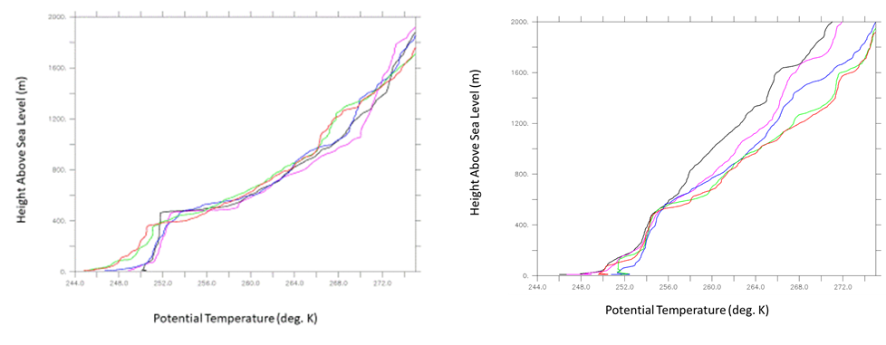
Figure A1 Winter potential temperature profiles over ARM’s North Slope Alaska site. (left) Dec. 30, 2020, (right) Jan. 06, 2021. 5:30 (BLACK), 11:00 (PURPLE), 17:30 (BLUE), 21:30 (GREEN), and 23:00 (RED)

Appendix B
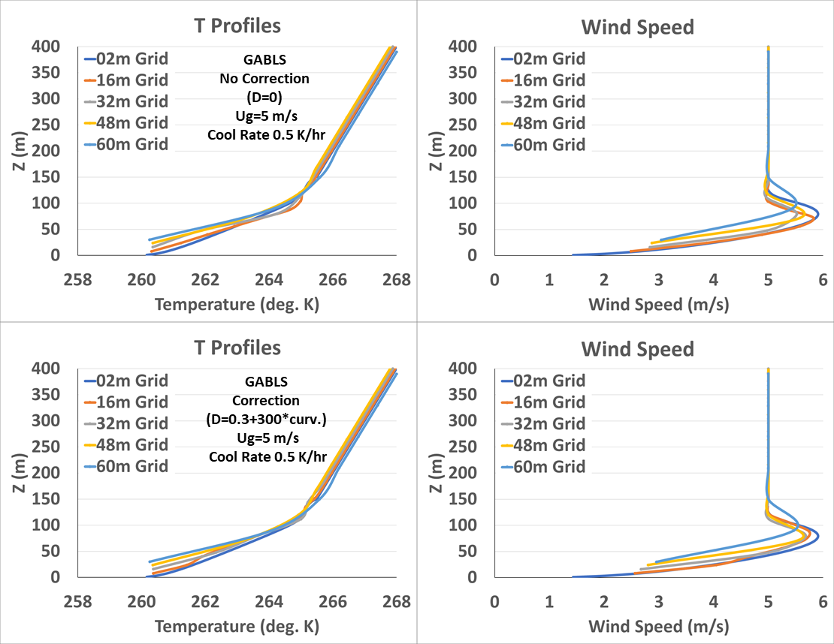
Figure B1 Plots of temperature and wind speed profiles for geostrophic wind speed of 5 m/s and cooling rate of 0.5 K/hr. Top uncorrected and bottom corrected using D in (8)

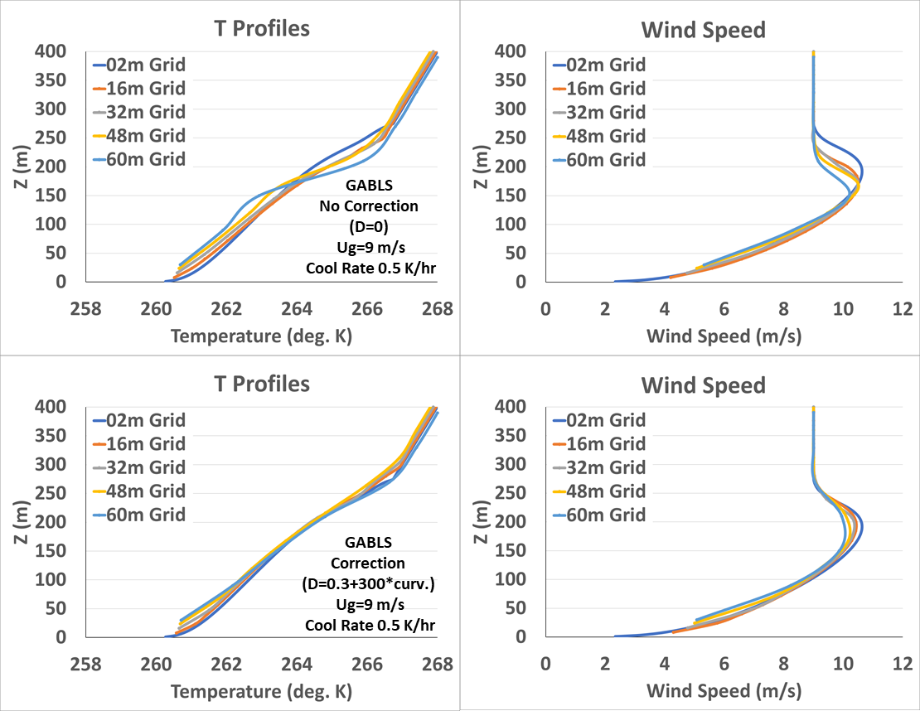
Figure B2 Plots of temperature and wind speed profiles for geostrophic wind speed of 9 m/s and cooling rate of 0.5 K/hr. Top uncorrected and bottom corrected using D in (8)

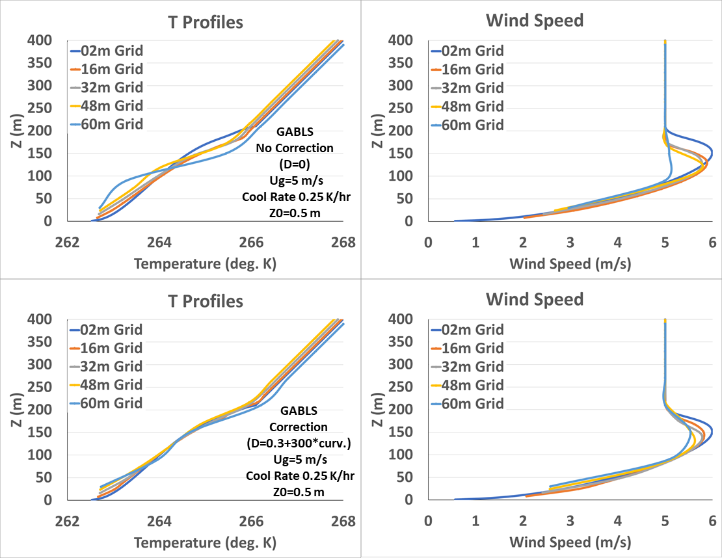
Figure B3 Plots of temperature and wind speed profiles for geostrophic wind speed of 5 m/s cooling rate of 0.25 K/hr and roughness 0.5 m. Top uncorrected and bottom corrected using D in (8)

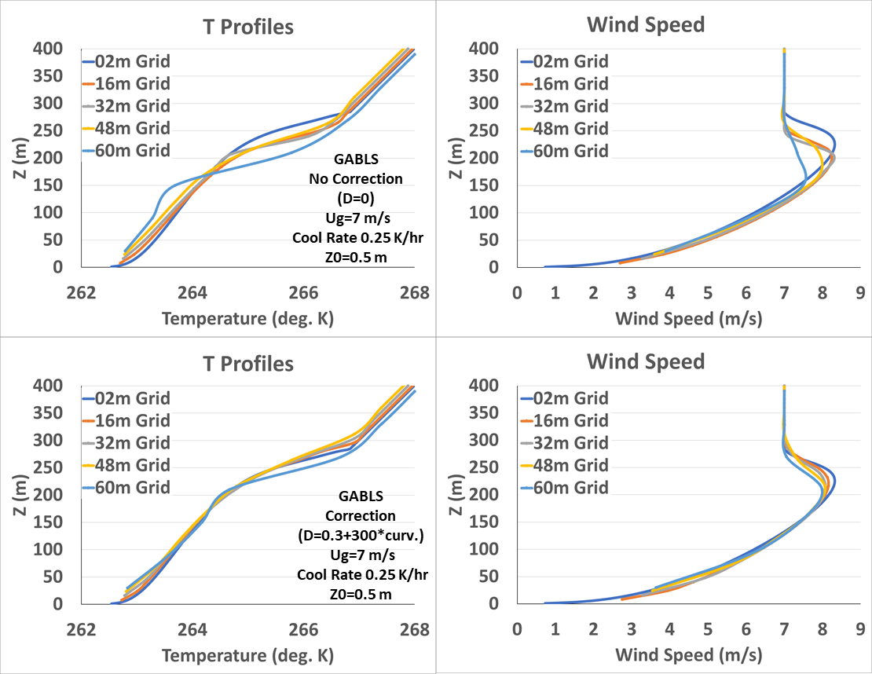
Figure B4 Plots of temperature and wind speed profiles for geostrophic wind speed of 7 m/s cooling rate of 0.25 K/hr and roughness 0.5 m. Top uncorrected and bottom corrected using D in (8)

